Austin Marathon Trip Notes
February 11-16, 2010

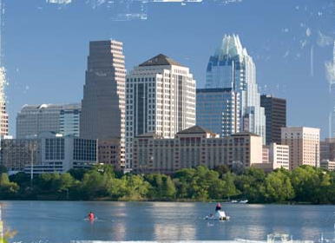
Why Austin?
- Live music capital of the world. Over 200 bands playing every evening and 1700 during festivals.
- Big City Meets Small Town
- If it’s good enough for Lance, it’s good enough for me.
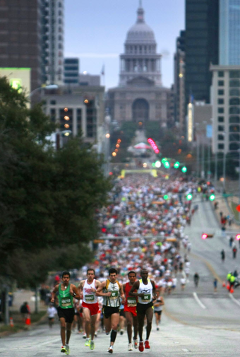
- Convenient and vibrant downtown area.

Why Austin Marathon?
- I’m beginning to think that I should stick to Texan marathons . . . .
- One of 25 largest marathons in the country with 13,000 runners yet with a small town feel.
- A free iPhone App that was amazing.
- Paramount Theatre with four of Texas' finest singer-songwriters to share the stage in an intimate setting of the historic Paramount Theatre as a festivities kick off.
- It’s warm while we’re cold in the east. Well, sort of warm with temperatures falling into the 30s but that was unusual.
- The course was a delight covering downtown, the river, a famous golf course, the lake and some pretty diverse neighborhoods. If you want variety, you’ve got it here.
- Amenities are amazing with a very nice weekend-sized backpack given at the expo and a nicely styled tech-shirt at the finish line.
- Bib includes your name if desired. Chip is a disposable.
- Shirts were in women’s sizing. A nice and always needed touch.
- Starting line is within an easy walk of many hotels. Finish line was close by and also near to hotels.
- As many bands as any rock ‘n roll marathon.
- Medal is a richly heavy metal, shiny gold color, with a quality ribbon. Top that with a little heart decoration thrown in since it was Valentine’s Day and it was unusually classy.
- A food court was offered at the finish line with picnic tables and great offerings by local businesses with local foods.

Said to be one of the fastest marathons around and that could be true but I think the statistics could be skewed. Austin is a very young city with an average age in the low 30s (maybe due to the university). There is a rather large purse offered so speedsters will be prone to attend. It seems that the course used to be point to point whereas now it’s a great big loop. I loved it but there were plenty of hills and one should look up the elevation chart before expecting flat and fast.

Surprises
- A 9-year old competed in the half marathon.
- Pasta party isn’t needed in this party town with multitude of entertainment districts and huge number of restaurants.
- Nice expo facilities and its close to the host hotel but a bit too far away from the start line.
- At the starting line there was a special effects rock & roll style stage pyro above the starting line truss. It was 50 feet tall and lasted for about 20 seconds and was enough that I could see it a couple blocks away.
- Weather had been unusually cold and the prediction was to not top 52 degrees but the day saw 68 degrees before I got in.

Could use some work
- Porta-potties: I can never forgive race organizers for not providing sufficient numbers of toilets. There was always a long line.
- Food was practically non-existent though I could tell there had been some oranges and bananas for the faster runners. Now who do you think needs it the most? Yeah, let me hear it for the back of the packers.
- No discounts for USATF, or 50-staters, or Marathon Maniacs.
- Pacers only up to 5 hours. Don’t they know that us 5:30s need them?
- Why the host hotel is farther away from the start line than many other hotels is a mystery but maybe because it’s near the expo.

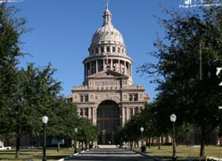
Hotels and proximity: I was in the Residence Inn which was connected to a Courtyard, both by Marriott. These were perfect locations and I think much better than the host hotel which was across the river. The Hampton Inn would have been good also and was closer to the starting line if you’re an elite runner. I walked out of my hotel at 6:50am for a 7:00am start, two blocks on 4th Street where the pacers were lined up. The starting line was on 2nd Street closer to the river and closer to the Hampton Inn. The La Quinta Inn was closer to the finish line which was near to the Capital. The start and finish were on Congress Avenue, always with a direct view of the gorgeous state Capital building.

Amenities and the medal were worth writing home about. Here are some pictures from the rich and heavy medal that’s a lovely design, to the high-tech and fitted t-shirt, to the backpack that’s full of zippers, padded shoulder straps and large enough for an overnighter.

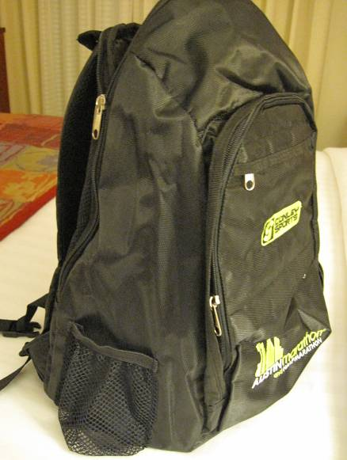
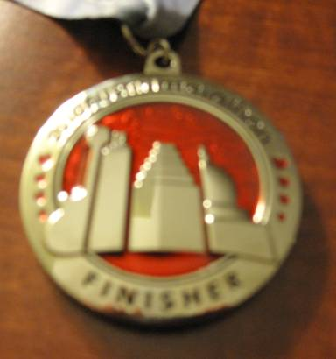

Tourism that’s what it’s all about – I mean really, do you think a back of the packer goes to these towns strictly for the marathon? I love seeing the course close up and 26.2 miles at a time but I equally love the bus tours, the walking tours, the ghost tours, the downtown bars and restaurants, the history, the river and lake trails, and Austin’s got it all.
I’ve been collecting visits to presidential libraries and while I can’t say that of Lyndon Baines Johnson was the best, it was worth an afternoon and the price was right – free. Stark and a wee bit political, it bears LBJ’s and Lady Bird’s personal touches while they were alive. There was a special exhibit of Presidents and their Education with mementos from other libraries. I’d seen quite a few of them already.

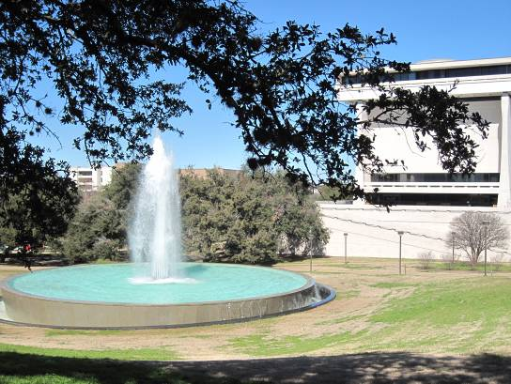
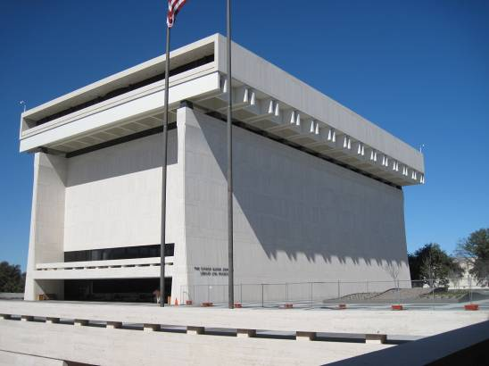
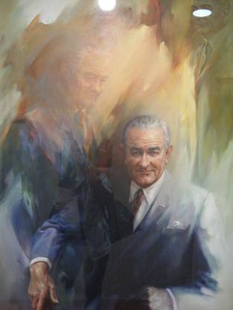

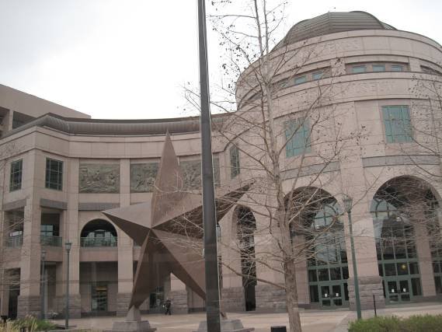
Avatar in Austin? This will sound even sillier to those who know me. Know that I don’t do movies. But Avatar is another story with it being a top grossing movie already at over $1 billion, all new technology, and in 3D. That might not have tempted me but when I went to see The Story of Texas on a huge screen IMAX and found Avatar playing instead, I stayed. Or I tried to. Friday night, having walked about 40 minutes one way to the Museum I found the show sold out. Saturday afternoon I went early to purchase a ticket thinking I’d have lunch at the adjoining Museum of Art and visit the Museum before returning to see Avatar. It was not to be – it was sold out again. Though Sunday night at 8:30pm after the marathon for a 2 hour and 40 minute movie was not ideal, I bought a ticket and trudged back in unusual freezing temperatures with wind gusts of 25-30mph. Did I see Avatar? After 1 hour and 45 minutes the film broke. Luckily friends explained the ending. It was gorgeous and striking and worth my three long walks in the cold to see it but I was stunned at the violence and even more so when I realized that children are watching it.

Here the museum where it was showing and the displays on Texas were excellent. But the cafeteria had run out of food. I was jinxed? They were probably happy to give me a credit instead of trying to show me the movie again.

This is said to be the largest star in the Lone Star state.

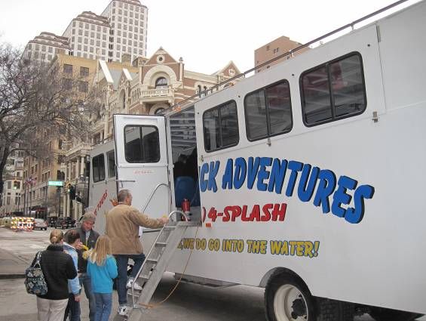
The river and ducks
Austin is built on two sides of a river, so it’s inevitable there would be a duck tour. I generally find these tours to be frivolous and yet off season they are better than nothing. The tour guide made this one worth it. It was not in the usual historical boat/bus but rather a specially fabricated one purchased in Washington.

A bus tour too
Though downtown and being on my feet was perfect, it being a huge entertainment district, I jumped at the chance to take a bus tour which would give me 30 miles and 30 major historical and cultural points. These 30-mile tour droves past over 30 major historical and cultural points of interest far too fast but some I was able to return to, and some we ran past during the marathon so it was well worth it. We learned some history and geology of Austin and saw and learned: Austin City Limits - KLRU -- Austin Convention Center -- Barton Springs -- Barton Springs Road -- Restaurant Row -- Bob Bullock Texas History Museum -- Zilker Botanical Gardens -- Bremond Block -- Brief Geology Lesson -- Brief History of Highland Lakes System -- Brief History of Texas -- Camp Mabry -- Congress Avenue -- Congress Avenue Bridge and Bat Colony -- French Legation -- Harry Ransom Center -- Hill Country views on 2222 and Loop 360 -- J. Frank Dobie House -- J. Blanton Art Museum -- LBJ Presidential Library -- Long Center for the Performing Arts -- Mayfield Park and Laguna Gloria -- Moonlight Tower -- Mount Bonnell -- O. Henry Museum -- UT Performing Arts Center -- Santa Rita Oil Rig -- Sixth Street -- Texas Capitol Building -- Texas Governor's Mansion -- Texas Memorial Museum of Science and History -- Texas State Cemetery -- The Drag -- Town Lake and Auditorium Shores - Palmer Events Center -- Travis County Court House -- Treaty Oak -- Umlauf Sculpture Garden -- University of Texas at Austin -- UT Royal Memorial Stadium -- The Warehouse District -- Wild Basin Wilderness Preserve -- Visitors Center -- Zilker Park

Some of you might best appreciate Mt Bonnell – its where the rich and famous live to include three homes of Lance Armstrong. Here’s a view from Mt Bonnell and Congress Avenue Bridge over Town Lake. The picture of the Texas Governor’s Mansion is a canned photo since it’s enshrouded in scaffolding currently following the bomb attack. Yep, it was immediately after I left that the small aircraft bombed into the IRS center. You’ve seen those pictures now.
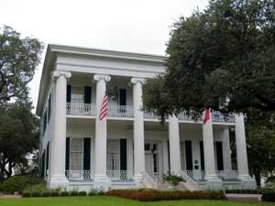
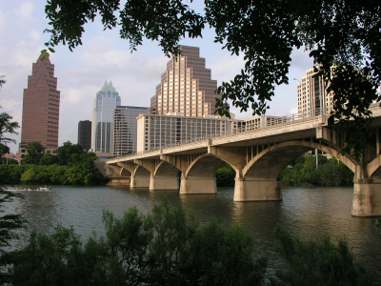
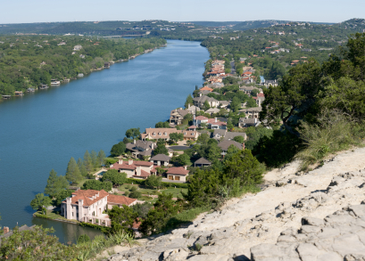
Walking tours too
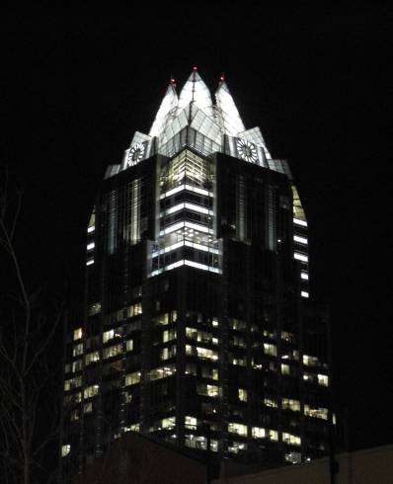
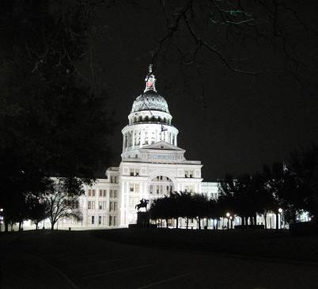
You’re asking who goes to a marathon and takes two – yep, two! – walking tours on Saturday? I didn’t have to work very hard to be true to myself. I’m there to tour and lucky I did because Austin’s historical society has wonderful walking tours and they are totally free. Just shiver and walk. There were also ghost tours but I had shivered enough and besides I had walked two of the nights to see Avatar on the IMAX so I was just too busy walking.

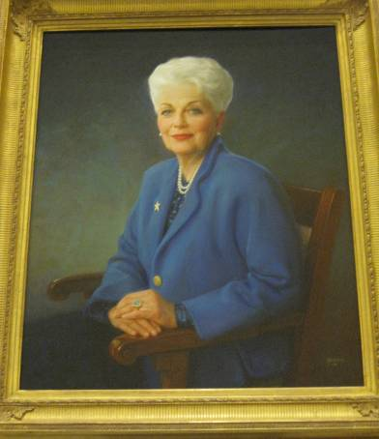
Inside the state capital
It’s supposed to be taller than our nation’s capital and certainly it’s dramatic. I took a walking tour here too, both inside of this ancient and well preserved red granite building and outside in the heavily sculptured gardens. It was in the portrait gallery where I found Ann Richards. She was an early inspiration to me when I learned that she worked out and could leg press 160 pounds. I told my weight trainer and forevermore I was reminded that I was a wimp if I couldn’t out-press old Ann Richards and I did get up to 190 pounds before taking up marathoning and using up my muscle mass. Here’s the old gal.

Outside too with guess who?

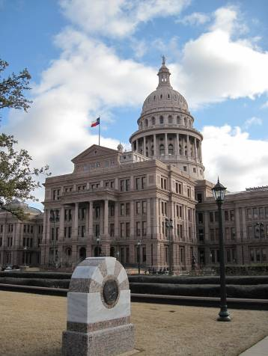
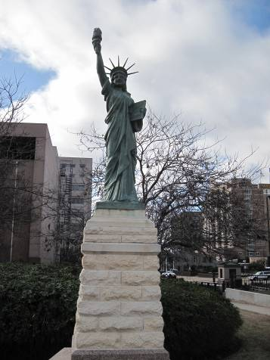
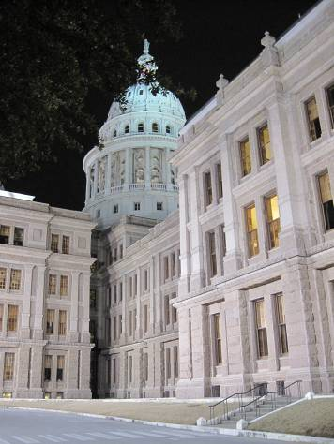
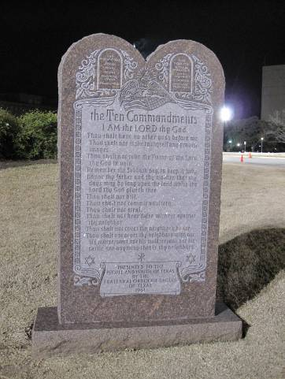
Remember the famous Ten Commandments Monument case?
They finally took the question to the Supreme Court and won the right to retain the monument of the Ten Commandments based on the fact that the public didn’t pay for the monument. There’s hope for our world after all.

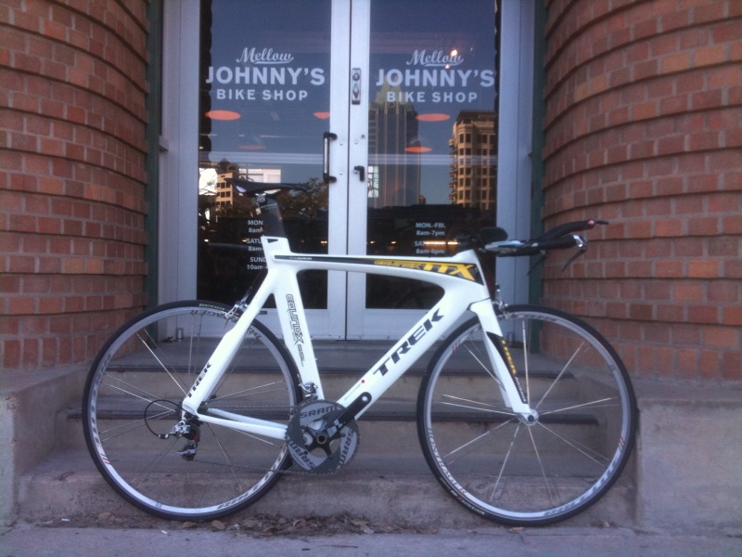
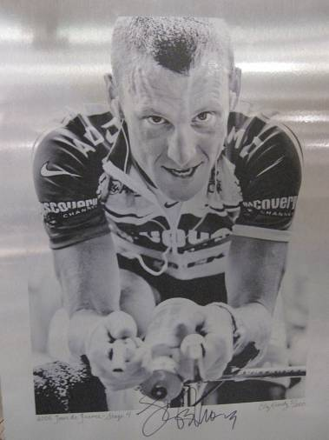
Mellow Johnny’s – This is Lance Armstrong’s bicycle shop in Austin and I think the name comes from a misunderstanding of the words Maillot Jaune, French for yellow jersey. The story is that a bicycle was stolen from his team and it was nearly irreplaceable. Well, it has been recovered and returned to Mellow Johnny’s Bike Shop. It was discovered at a flea market in Mexico and just recently made it back to Austin. Thieves had smashed a glass back door at Mellow Johnny’s to get the bike, valued at more than $10,000. The bike, bearing Bauman’s name, traveled south through Texas and eventually landed at a flea market in Guanajuato, Mexico. A cyclist purchased it for a bargain, but it was recognized by his local Trek dealer when he brought it in for service.

Lance is quite respected in the Austin area and has been instrumental in forming many bike paths and lanes. He had a booth at the Marathon Expo.

Other celebrities are numerous – does everyone come from Austin?
Everybody was talking about Brooklyn Decker, the wife of their tennis star Andy Roddick. Seems the wife is getting better known since she just came out (is that the word?) on the cover of Sports Illustrated. Lance Armstrong has at least three houses in the area, one designed by he and Sheryl Crow, and one where his wife Kristin and his children reside. Sandra Bullock has a house on the lake and Bonnie Raitt is a part time resident.

Heard on the street – or was it by email?
Canceled: Myrtle Beach SC Marathon on Saturday February 13.

Postponed: George Washington Marathon in Greenbelt MD on Sunday February 14. The eighth longest-held marathon in the United States was postponed due to expected unsafe road conditions in the Greenbelt/Beltsville area. The Race Directors are researching whether it is possible to reschedule the race, tentatively for Sunday, February 28th or Sunday, March 28th.

Come hell or high water: Sunday February 14 Mercedes-Benz Marathon Weekend announced “All races will take place regardless of rain or snow!”

Headline: Marathoning Alive And Well in USA - 2009 Shows Unprecedented Growth
As we complete our year-in-review reports There were nearly 468,000 marathon finishes in the USA in 2009 - an increase of approximately 9.9% over 2008. That's the largest year-to-year growth in finisher numbers since MarathonGuide.com began keeping industry records in 2000 and surpasses even the year-to-year growth seen in the abnormal year of 2001 to 2002 when travel and finisher numbers were down in 2001 after 9/11, leading to the unrealistic growth percentage in 2002. As has been the trend, women continued to make up a higher percentage of the total finishers, reaching a record 40.5% of finishers in 2009.

Sorry – or also known as -- Austin ranks as 5th drunkest city
What? Austin is drunker than New Orleans and Las Vegas? Is that even possible? Men’s Health magazine just released its list of drunkest cities, which ranks 100 major U.S. cities in terms of sobriety, and Austin ranks fifth. Fresno, Calif., came in No. 1. Reno, Nev., was second, followed by Billings, Mont., third; and Riverside, Calif., fourth. Two other Texas cities made the top 10 — San Antonio was No. 6 and Lubbock was No. 7. Houston came in 47th and Dallas was 77th. The magazine considered death rates from alcoholic liver disease, alcohol-related car crashes, reported binge-drinking rates, number of DUI arrests, and severity of DUI penalties in calculating its list. Men’s Health also gave each city a letter grade based on its score. Austin got an F. I think the University of Texas, Sixth Street and, possibly, those purple margaritas at Baby Acapulco’s may be to blame. Somehow, Vegas came in 11th and New Orleans 21st. Isn’t drinking a national past time in those cities? Ever hear of The Strip or the French Quarter? Boston fared best (or worst, depending on how you look at it, I suppose), at number 100. Compliments of www.austin360.com.

Weather and results
I was rough on my body both Friday and Saturday (two walking tours on Saturday plus a jaunt across town) so I should be happy to be done at all. I came in happily, with a smile and not limping, at 5:45.
It was warmer than predicted and had I worn the clothing I planned the night before, I'd have been perfectly dressed. But I looked at the weather alert at 6am, saw a major wind storm coming in and a foggy/cloudy day, so I added another layer plus a warm hat. I didn't need either. There was never any wind and plenty of lovely sun with not a cloud in the sky. (Until later.) The prediction was for 42 degrees at the start and 56 degrees and cloudy at the end with wind kicking to 10mph. In reality, I had to keep my trash bag on for the first couple miles and at the end it reached 68 degrees with nice sunshine and barely a wisp of clouds in the sky. No wind. Until later. Lesson? Wear layers which fortunately I did and peeled some off but the planned baseball cap would have been better.
This was nearly my 8th DNS (Did Not Start or Did Nothing Stupid)
The day before my departure to Austin from Newark wasn’t looking good. The weather was dumping a lot of snow for the third time in a row. But the snow gods played favorably and the shoveling was possible just before departure time and all is well. Here are a few shots of the weather beaten home gardens which will never be the same. (Yes, the pond is heated.) Pictures show the first pond, our house from the street, and from my office desk looking over the back pond.

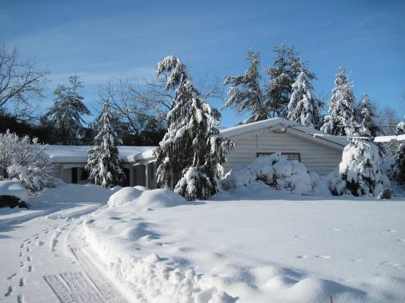
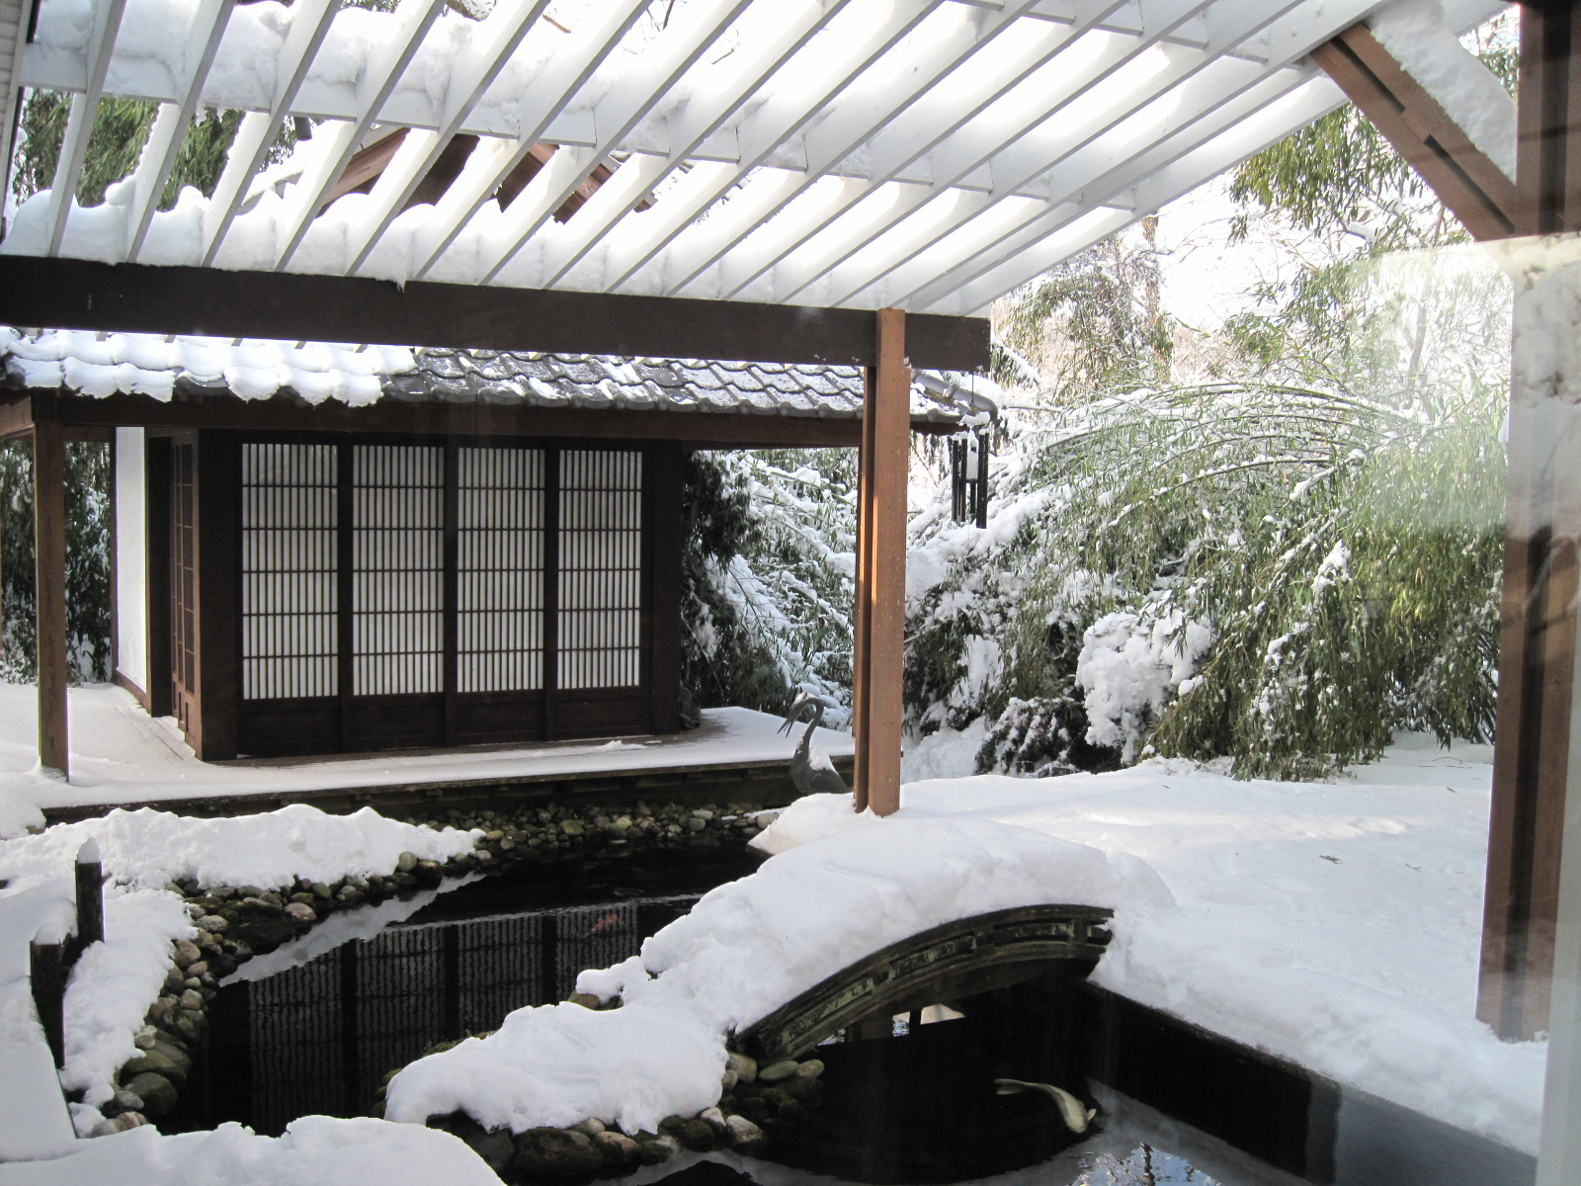
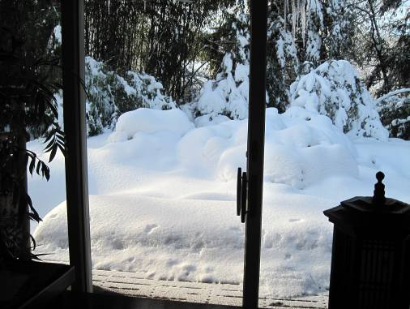
Is there more? Heck yes. I have a few hundred photos that I’d love to share but I need to pack for my next adventure: On February 23rd Tom and I depart for Palm Beach where we’ll stay at The Chesterfield Hotel, my home-away-from-home for my nearly 7-year commute that ended in 2007. We’ll venture on to Tampa where I’ve registered for the 10th and final running of the Gasparilla Marathon, and then we’re on to St Augustine to see the city created by Henry Flagler and said to be one of the oldest in the country. We return home in time for me to re-pack and head out to Annapolis to participate in the B&A Marathon and celebrate the 50-state running completion by friend David Williams. Fellow Liberty Lady Maricar will be in Annapolis for this celebration.

March Madness
March will test my legs with 4 marathons in 5 weeks, starting with Tampa and B&A, DC’s National, and finally Ocean Drive in Cape May where dear friends Marv and Maryanne Winters from Tulsa are getting near to their 50-state completion too. Maricar will be in DC’s National but then she’s off to Europe with her students so will miss seeing if my legs survive March Madness.

A farewell to Bosco
March Madness marked my entry into marathons in 2002 and it was George “Bosco” Boscarino who paced me in my first ever race in March at E. Murray Todd Half Marathon. It was Bosco who took care of all of us at New Jersey Road Runners Club each and every Sunday no matter the weather, no matter his health, no matter the situation. It was Bosco who bused us to all our New York City Marathons and arranged for food and massage thereafter. It was Bosco who was a mainstay at all our New Jersey Marathons, working 24/7. It was Bosco who formed www.BoscoBuddies.org for Hepatitis C Awareness and made us all aware of the growing threat. It was Hepatitis C that took Bosco from us today, February 19th, and we will all truly miss him, his gentle ways, his ever present smiles. We will be guided by his ongoing inspiration.

Itinerary

Thu 2/11/10
3:15pm Depart Newark via CO#450
6:29pm Arrive Austin

Taxi is $25 to $30 to hotel; Super Shuttle available

Hotel La Quinta Downtown Capital (1) for 2 nights
300 East 11th Street, Austin TX 78701 Tele: 512 476 1166

Fri 2/12/10
Am LBJ Presidential Library if in walking distance –1 to 1 ½ miles

Move out of La Quinta to Residence Inn or wait until Saturday morning? Appears to be 7 blocks or .47 miles.

3:00pm Expo at Palmer Events Center, 1.12 miles from Residence Inn, until 7pm
900 Barton Springs Road, Austin TX 78704 – there is public transport

Hotel Residence Inn by Marriott Downtown (2)
300 East 4th Street, Austin TX 78701 Tele: 512 472 5553
To Hyatt (host) hotel is .72 miles per mapquest. Across the bridge.
To Expo is 1.28 miles; To start is .41 miles; To Finish is .42 miles

Sat 2/13/10
10:00am Expo at Palmer Events Center until 6:00pm

Sun 2/14/10
7:00am 18th annual Marathon – www.youraustinmarathon.com – Bib#843
Sold out by January 2010 at 5,000 and 9,000; Also sold out early in 2009.
Starts at Congress and 2nd Street. Finishes at Congress and 10th Street.

The Austin Marathon is USATF certified loops that run through some of Austin's most scenic and historic areas, including Lady Bird Johnson Lake, the Allandale and Hyde Park neighborhoods, Congress Avenue, the University of Texas campus and the State Capitol complex. The gently rolling and shaded course is 90% asphalt with long straight-aways and approximately 28 turns. The marathon course gains approximately 14 feet per mile over the first 17 miles before dropping over 33 feet per mile over the final 9 miles to the finish on Congress Avenue in the shadow of the State Capitol building. See course map in file.

Pacers only to 5 hours but course open for 7 hours.

New this year is the Marathon’s food court with tasty treats from locally owned Austin restaurants. Race participants are encouraged to enjoy light refuel food in the finish line area courtesy of HEB before meeting family and friends for heartier fare in the food court. Please remember to tuck some cash away as the food court does not accept credit cards. Some of the restaurants providing food are Wahoo's Fish Tacos, Sugarstar Cupcakes, Lucky J's, mmmpanadas, and Hat Creek Burger Co.

Also new is iPhone app with map, results and links.

Tue 2/16/10
2:30pm Depart Austin via CO#351
7:25pm Arrive Newark

(1) The newly renovated La Quinta Inn Austin Capitol is located in the heart of downtown Austin near the Texas State Capitol Complex and the University of Texas Campus. With La Quinta as your home base, you have easy access to all popular area attractions: Sixth Street Dining and Entertainment District, West End Shops and restaurants and a local brewery, the Convention Center, and Texas State History Museum. Tour the area in a "Duck", a six-wheel drive military power vehicle. View a massive population of bats at the "Bat Bridge". Ride the Austin Steam Train. Visit LBJ Wildflower Center, Austin Children's Museum, Alamo Drafthouse Cinema, LBJ Library, or cheer on your favorite University of Texas sports team.

(2) The Residence Inn Austin Downtown is adjacent to the Austin Convention Center in the heart of downtown Austin's business district and has the amenities the seasoned traveler expects. Comfortable and functional, this Austin extended stay hotel has spacious suites with queen beds and queen sleeper-sofas, complimentary high-speed Internet access, plenty of workspace, and full kitchens. To ensure your day starts and ends on a good note, the Residence Inn Austin Downtown offers a free hot breakfast everyday and an evening manager's reception M-Th. By choosing this Austin extended stay hotel, you'll have easy access to all Austin has to offer for business and pleasure. Convenient to the State Capitol and UT, the Residence Inn Austin Downtown is center to Austin's famed 6th Street and Warehouse Entertainment district and surrounded by a bounty of live music venues.

First Stateside Marathon - interesting (about: 2009)
Course: 4 Organization: 5 Fans: 5
D. G. from New Jersey - Air Force (3/29/09)
4-5 previous marathons
This was my first stateside marathon, and it was a tough run. If you HAVE NOT trained, this would not be a good one to run.
The first half of the marathon was okay, but the second half was GREAT! The water stations were lacking the first half, but they made up for it the second half. There was a section that we actually got bottle-necked, which can be frustrating.
Hills? Yes there was hills and I don't care what anyone says... having a hill within two miles of the finish line can be rough!!!
I didn't train, so it was not one of my better runs, but overall... I loved it!!!
Great t-shirts and finisher's medal!!!

Fun destination marathon, but could be improved. (about: 2009)
Course: 4 Organization: 3 Fans: 5
M. M. from Valencia, PA (3/5/09)
4-5 previous marathons | 1 Austin Marathon
I traveled from western Pennsylvania to run the marathon on my birthday. I picked this marathon for the hills, crowd support and the fact I had never been to Texas. The Austin restaurants that we went to Friday and Sunday evening were great. The pasta dinner the night before was just so-so, but meeting Bart Yasso and Dick Beardsley was fun.
Running in the neighborhoods was interesting, but you could lose the tight alleyway at mile 3. The crowds were enthusiastic and all of the volunteers were friendly and helpful!
I anticipated seeing more of the University of Texas during the race. I didn't even realize that we had passed it.
The race was 20 minutes late getting started. No announcements, no sound system to inform the runners waiting in the middle and back of the pack.
My suggestions for the race in the future: Continue to highlight the neighborhoods, but feature the University of Texas campus. Have a sound system for announcements. Keep the hills, but lose the alleyway on mile 3.

Great Fans, Solid Organization, Average Course (about: 2009)
Course: 3 Organization: 4 Fans: 5
S. S. from Wilmington, DE (3/3/09)
1 previous marathon | 1 Austin Marathon
The fans make the experience at Austin. The scores of spectators are extremely supportive and many go out of their way to help you through the race by handing out anything from oranges to gummy bears. One guy even had GU; what an animal.
The race is well organized. There are plenty of water stops. The start and finish are well handled. The medals for finishers are excellent. Philly Distance Run is a five in the organization category, and this race was not quite on that level, but well done.
The course was disappointing. The first ten miles are fine. Then you get out on the highway around town and the scenery is just plain boring. At the very end of the course there are two ridiculous hills that forced many competitors to walk. I'm all about hills but the two at the end just seemed like overkill when the rest of the course has a lot of hills with pretty intense grades.
Overall, the race is well done and going to Austin, which is a great town, makes this race worth it. I do wonder if the race would have been better if AT&T had not backed out at the last minute. A lot of elites bounced on the race once the AT&T left with the purse.

Hills, Shmills. Great race (about: 2009)
Course: 5 Organization: 5 Fans: 5
G. S. from Harker Heights Texas (3/2/09)
6-10 previous marathons | 1 Austin Marathon
The second most difficult course of the seven I have run. Hills were a challenge; however, the support and the bands were top-notch. Raves for the pacers. I dropped my PR by 18 minutes. See you in Boston next spring. Great race in a great city.

Fab Spectator Support (about: 2009)
Course: 4 Organization: 5 Fans: 5
R. E. from Florida (2/26/09)
3 previous marathons | 1 Austin Marathon
I HIGHLY recommend this race, even though my time was much slower than I wanted. I agree with the comments from other runners. The crowd support was amazing for the ENTIRE course. I've never seen so much support, other than NYC. But here, the spectators were offering food, tissues, and very witty signs. Some of my favorites: "May the Course be With You," "Run like you Stole Something," and "Defense" (hey, it's a college town and this is all he had).
This course is challenging, with the hills, hills and more hills, especially at the end. Hopefully they will change that, along with the narrow path around mile 3. There was a nice, flat stretch for miles 17 - 23, which was really welcomed. The volunteers were great (but I always wish they would put water in different colored cups from the energy drinks). I wish there were more port a potties along the course. I didn't even attempt to stop until the half-marathoners turned-off. I got to mile 18 with only 2 in line to wait, so I took that opportunity. The expo was FABULOUS, very organized, huge, and had lots of vendors. The medal is beautiful and substantial. As a marathoner, I did receive a technical finisher's t-shirt. I would definitely run this race again (but since I know about the hills, I do have some hesitation; I'm from Florida where it's very flat). In summary: great city, great organization, great expo, great spectators, great race. Just go for it.

Tough course but great city support! (about: 2009)
Course: 3 Organization: 5 Fans: 5
m. r. from Iowa (2/24/09)
6-10 previous marathons | 1 Austin Marathon
Personally, I had a "bad day" in Austin. I was sick with the flu and didn't even feel like running. This fact does not take away from the awesome job that the entire city of Austin did on this gorgeous February day!
The course was hilly, as others have noted, but I was expecting it and that's half the battle! The tight alley-area at mile 3 was fine and nothing to complain about. The hills toward the end, near U of T campus, were just brutal. The major complaint I had about the course was the finish line: it was turn after turn and you didn't see the very end until the last 50-100 yards. Seeing the finish line usually gives me an extra "push" (as much as you can muster in a 26-mile-long-run), but I didn't get that with such a short "chute." The crowd along there was great, though.
Speaking of which, the course support (police and public fans) was amazing!!! There was almost always somebody cheering you along and traffic control was top-notch. At one point, I had to stop and catch my breath due to foot pain and a nice spectator offered me a GU or water out of her own bag! The music was not the best (too sparse), but it was better than nothing.
Another thing I liked about this marathon was its size. I think there were about 14,000 runners total (half and full) and that seemed to be just right. You were always running with someone, but not necessarily bumping elbows. Perfect.
I enjoyed the concept of a marathon "going green," but I didn't like registering on Active.com where you are charged an additional fee to do so. (Perhaps that fee can be waived, since it's the only choice for registration.)
I LOVED the chicken noodle soup at the finish line!! Yummy!
Great medal and tech shirt.
Thank you to the City of Austin! We loved visiting such a fun (AND WARM!) city for the weekend.

Too many hills!! (about: 2009)
Course: 2 Organization: 3 Fans: 5
M. W. from Atlanta, GA (2/23/09)
4-5 previous marathons
I agree with most of the earlier comments. Too many large hills toward the end of the course and the finisher shirt should be a technical shirt like they offer at other races.
Austin is a great city and the crowds were amazing. These changes could help make the Austin Marathon a great race.

Very hilly! (about: 2009)
Course: 4 Organization: 4 Fans: 5
M. D. from Virginia (2/22/09)
4-5 previous marathons | 1 Austin Marathon
In the comments section of just about every marathon, you will find someone exaggerating the magnitude of the hills. Well, I found out first hand that the comments about Austin are NOT exaggerated - very hilly! Don't let this discourage you though... the course is doable - just make sure you prepare.
Other than that, the race was done very well. Austin is a great city and the spectators at the race were phenomenal! At other marathons I have done, the crowd usually becomes non-existent after the half marathon split. Not here - the fan support was fantastic from start to finish! Medal was very nice, finish line food could have been a bit better, but the chicken noodle soup really hit the spot!
And as for the comments about pouring your own water at water stations?!? Not sure sure what race and/or pace that person was running - I had absolutely no issues and found the water stops to be adequately staffed with hard working volunteers. And most of the time they encouraged me by name as they handed me water (your names are printed on your bib). Top-notch volunteers if you ask me....

Hills? You Call Those Hills? (about: 2009)
Course: 4 Organization: 5 Fans: 5
m. b. from Albany, CA (2/22/09)
11-50 previous marathons | 1 Austin Marathon
A couple months before the Austin race I started getting warnings from locals about the hills and that I'd better be doing some serious hill training. I took that seriously and stepped up said hill work. Then I drove the course the day before the marathon and wondered where the hills were. True, there are a couple of fairly steep inclines, but they are very short - nothing like the 8-mile climb at the beginning of the New Mexico Marathon or the near-killer from 18-20 on the Loch Ness Marathon course... or the many hills of San Francisco. Austin is a challenging course, to be sure, but I'm not sure it was because of the killer hills. The expo was better than I expected, the crowd support was amazing, and the volunteers and organizers did a great job. And... Austin itself just rocks. A great place to spend the weekend. Would definitely do this one again.

Loved the challenge and the spectators (about: 2009)
Course: 4 Organization: 5 Fans: 5
R. M. from New York (2/21/09)
2 previous marathons | 1 Austin Marathon
I like the course. I like the challenge of the hills even though those few smaller ones at the end killed me....
I was well prepared for the course and knew what to expect. Volunteers and crowd where great all throughout the course. I didn't have any problems with mixing of half and full marathoners, nor an issue with the tighter road around mile 3.
I heard the race director say that they may change this course in the future so that it does not disrupt downtown. I hope they don't make that mistake. The course is great as is, and they should not worry about "disrupting' downtown residents - that is part of why you live in a city, to get access to the city's best events.
Great efforts to keep the event environmentally sustainable also, which I applaud.
I ran a PR and beat my goal time, despite blowing up in the last 3 miles.

About Austin
Austin is a place where business professionals, artists, musicians, filmmakers and students all bring their passions to life. Even with its population growing rapidly, this city continues to welcome new residents with open arms. Over the past few years, several national magazines have touted Austin as a top place to live.
Sixth Street - To experience "The Live Music Capital" of the world, Sixth Street is a good place to start. Often closed to vehicle traffic on the weekends, this street is lined with dance clubs, live music venues, eateries and street musicians, plus several tattoo and piercing shops. Visitors can have their tarot cards read by a gypsy on a street corner, or buy handmade jewelry from artists and hippies. Grab a slice of pizza at Roppolo's when the munchies take over; or, if a Cajun meal is what you're after, Roux & Parish serves up Louisiana cooking and great mixed drinks. Music fills the air in this area every night of the week, and visitors can hear everything from country to hip-hop, blues to noise-pop.
If you venture north on Red River Street, you'll find some of Austin's best live music venues. Emo's, Stubb's and Red Eyed Fly all reside here.
The Capitol Building - Built in 1856 and 1857, the Capitol Complex Visitor Center is the oldest remaining state office building in Texas. In 1997, it underwent an enormous restoration and extension. Inside the Capitol Building, there is an exhibit chronicling the restoration, where visitors can view a 20-minute film narrated by Walter Cronkite, titled Lone Star Legacy: A History of the Capitol. The Capitol is a Renaissance Revival-style building made of Texas pink granite and native limestone, overlooking Congress Avenue. Guided tours are free and provide interesting information and anecdotes for visitors. Make sure to stand in the center of the Rotunda, look up, take notice of the Texas star and enjoy the beautiful architecture.
Congress Avenue - As you are heading south on Congress Avenue, stop by the Austin Museum of Art and check out their collection of 20th-century artwork. Or, if you are in the mood to shop for unique gifts, visit Tesoros Trading Company, where you will find a large selection of Mexican and Latin American jewelry, folk art, amulets and collectibles. Many locals buy their Day of the Dead supplies here, as well as Peruvian good luck charms and Latin American Christmas ornaments.
As you travel further on South Congress and cross Lake Austin, you'll encounter a whole new environment. Starting with G??ero's Taco Bar, you will notice that South Austin has a different kind of energy - relaxed and funky. Here, you will find antique shops, retro resale shops, vintage clothing and folk art. Stop by Terra Toys to check out their collection of tin soldiers and chemistry sets, then head over to Texas French Bread for soup and a sandwich.

Zilker Park - Zilker Park is a 400-acre park home to natural, spring-fed Barton Springs Pool, a miniature train that circles the park for children to ride, a giant playscape, picnic grounds, rugby and soccer fields, a disc golf course and canoe and kayak rentals. At Christmastime, one of the city's moonlight towers serves as the trunk for the Zilker Park Christmas Tree. Thousands of colored lights are strung to form the shape, and each year locals and visitors twirl around underneath the enormous structure.
Enjoy a number of musical, dance and theater events at the Zilker Hillside Theatre, where the Austin Shakespeare Festival is held each year. Or, visit the Zilker Botanical Gardens, where visitors spend the better part of a day enjoying the cactus, succulents, roses, butterflies and special gardens - all for free.
Clarksville - Originally an African-American community half a mile outside of the city limits, Clarksville remains a melting pot of art and culture. Houses have increased greatly in price due to the location of the neighborhood and all it has to offer. Jeffrey's resides here, a restaurant for fine dining. You may also enjoy a visit to Nau's Enfield Drug, where you can order an old fashioned malt.

The Drag - The strip of business along Guadalupe Street, bordering the University of Texas, is lovingly called "The Drag." Many of Austin's coolest shops are here, including the Sound Exchange (CD's, records and tapes) and Blue Velvet (vintage clothing). Stop by the outdoor Renaissance Market, where you will find jewelry, clothing and gifts made by Austin artisans. If you're looking for live music any night of the week, head down to the Hole in the Wall. This small dive hosts live music seven nights a week, with free Sunday night shows. The back room is full of pool tables and pinball games, and the crowd features many regular customers. Walk a few more blocks and you'll stumble upon Vulcan Video offering rare cult films and indie classics for rental.

Hyde Park - Take a leisurely walk or drive through this Central Austin neighborhood and view its historic homes. You will likely see many residents working in their yards, walking pets or riding bikes. Duval Road runs through the neighborhood and is home to the vegetarian restaurant Mother's Caf?? and the popular Hyde Park Grill. This unique area, the city's first planned suburb, has its own small grocery store, and boasts a theatre in its name - Hyde Park Theatre. Stop by Dolce Vita Gelate and Espresso Bar for sweet Italian ice cream or check out Quack's 43rd Street Bakery for a cappuccino and a homemade muffin.

Attractions List
French Legation Museum - King Louis Philippe ordered Alphonse Dubois de Saligny of France to Austin in 1839 to become the French liaison to the Republic of Texas. He insisted on being called "Count" and built this home on 22 acres ... see more
O. Henry House Museum - Short story writer William Sydney Porter, whose pen name was O. Henry, lived in this home for three years while he spent time in Austin. It was constructed in 1891 and is filled with rare books, O. Henry's ... see more
Wooldridge Square Park - Nestled in between the Public Library/Austin History Center and the County Courthouse, you will find this lovely green space. Founded in 1909, this park with hills ... see more
Austin History Center - Built in 1933, this was the first public library building in the city. Showcasing artworks of that time with ornamental ironwork balconies and loggia frescoes, this building is now home to one of the state ... see more
Madison Cabin - From 1843 to 1912 this cabin was home to Henry Green Madison. After caring for eight children with his wife Louise in this cabin, they finally built a larger home in 1886. The Madisons built this new frame ... see more
Texas State Cemetery - This 18-acre cemetery is the final resting place of some of Austin's most famous military and public figures, including Stephen F. Austin, Barbara Jordan and nearly 2200 veterans of the Confederate Army. I ... see more
Neill-Cochran Museum House - Built in 1853 by Abner Cook, the master builder of the Governor's Mansion, this Greek Revival-style home is made with Texas limestone. Originally built as the Washington Hill House, the two-storey structur ... see more
Oakwood Cemetery - These beautiful grounds are the tranquil resting-place for over 23,000 people, including Governor James Hogg and his daughter Ima. The architect who designed the Governor's mansion, Abner Cook, rests here ... see more
Mary Moore Searight Metropolitan Park - This 344-acre park has an equestrian trail, a two-mile hike and bike trail, a fishing pier and an 18-hole disc golf course. Other sporting options include basketball, baseball, volleyball, tennis and socce ... see more
Bats Underneath Congress Bridge - The Congress Bridge over Town Lake houses approximately one and a half million bats in mid-summer. In the spring, the pregnant female makes her way north to roosting sites in the Southwestern United States ... see more
Windy Point Park - This privately owned park attracts many people. The park has showers, grills and dressing rooms for visitors to use, along with primitive camping sites for those who want to stay overnight. There are no RV ... see more
Wild Basin Wilderness Preserve - Founded by seven women, this area was used as an outdoor laboratory for science classes and teacher training. Located on 220 acres of land it offers 2 1/2 miles of trails reserved for pedestrians. No bikes ... see more
Capital Cruises - For cruising around on Town Lake, the best way to go is on a Capital Cruise. Have dinner with friends or just your date, while watching the beauty of Austin's downtown from the peaceful water. Sightseeing ... see more
Shoal Creek Greenbelt - Shoal Creek Greenbelt is a seven-mile trail that extends from Town Lake to 38th Street. The portion of the trail from 24th Street to 29th Street is designated as a no-leash zone, and hundreds of dog owners ... see more
Emma Long Metropolitan Park - This park offers over 1,000 acres of land with nearly a mile of lakefront. Visitors can go boating and utilize the park's two boat ramps. Skiing, fishing and relaxing on the sandy waterfront are also optio ... see more
Austin Carriage Service - For a fabulous weekend tour of the city or a romantic evening ride, this service is one of the premier ways to visit Downtown Austin. Tours begin at several of the major hotels, as well as at a number of d ... see more
Die Gelbe Rose Carriage Tours - One of the best ways to learn about scenic Austin is from the back of a Clydesdale-drawn carriage. Romance, historical and family fun tours are available by appointment; or if you are a wayward evening tra ... see more
University of Texas Tower - Standing 27 stories high, the University of Texas Tower (the main administrative building) is a fixture in the Austin skyline. Standing very close to the height of the Capitol, the observation deck provide ... see more
Zilker Botanical Garden - These twenty-two amazing acres overlook the Zilker Park fields bordering Barton Springs Road. The garden is actually comprised of several different gardens, including the Cactus and Succulent, Xeriscape, H ... see more
Commons Ford Ranch - This fabulous park is one of the Austin Parks and Recreation Department's premier facilities. Whether it is a family reunion or a company picnic, this park has all the amenities for a fabulous party. The u ... see more
Mayfield Park Cottage and Gardens - Mayfield Park Cottage and Gardens is open to the public but is a favorite among the City of Austin Parks and Recreation Department facilities rental division. The historic 1870s cottage is perfect for a sm ... see more
Walter E. Long Metropolitan Park - Just east of Austin, this park boasts some of the most popular activities for the outdoor enthusiast, including boating and fishing. Spend an afternoon taking leisurely hikes while enjoying this Audubon sa ... see more
Deep Eddy Pool - The water supply for the pool comes from an artesian well, and many are drawn to the fresh waters of this popular gathering place. A longtime favorite of locals for its sunbathing lawn and child-friendly a ... see more
Volente Beach - Located 30 minutes from downtown and offering boat rentals, cruises, and para-sailing. Enjoy the on-site restaurant or park your boat after a long ride. The new Water Park plays host to numerous water slid ... see more
Caswell House - Caswell House was Built in 1899 and located in central Austin, not far from the Capitol and the Governor's Mansion, this was once the home of a prominent Austin fam ... see more
St. Mary's Cathedral - St. Mary's Cathedral, designed by noted Texas architect Nicholas J. Clayton, is the oldest Catholic church in Austin. Construction was completed in 1884, but exquisite French and German stained glass windo ... see more
All Saints' Episcopal Church - This church was built by Bishop George Herbert Kinsolving, who is buried in a crypt underneath the altar. Created as a mission for St. David's Episcopal Church (the oldest Episcopal church in Austin), All ... see more
Congregation Beth Israel - The Congregation of Beth Israel opened the first synagogue in Austin over 120 years ago. Jewish residents lived here for a generation with no formal site at which to worship. But in 1876, a pioneering gro ... see more
Shree Raseshwari Radaha Rani Temple - The Shree Raseshwari Radaha Rani Temple, part of the Barsana Ashram, is the largest Hindu temple in North America. This striking building was constructed by Hindu artisans and is part of a 230-acre propert ... see more
Our Lady of Guadalupe Church - Our Lady of Guadalupe Church, the oldest Hispanic parish in Austin, was originally located on Fifth and Guadalupe. Built in 1907, the church was forced to move to its present location in east Austin in the ... see more
First Baptist Church - Legend has it that while serving in the Capitol, Sam Houston stopped on the corner of West 10th and Colorado, drove a peg into the ground and proclaimed, "I am a Baptist and right here we will build a Bapt ... see more
Inner Space Cavern - After being sealed for over 10,000 years, this cave was discovered in 1963 when a group of workers were digging to build a highway overpass. Daily tours are available and last just over an hour. The cave s ... see more
First Presbyterian Church of Austin - The First Presbyterian Church settled into a log cabin in Austin around 1850. Since that time, the church has moved to a number of different locations but throughout it all, the love of music reined suprem ... see more
Central Presbyterian Church - The Presbyterian Church has had a presence in the area since 1839, two and a half months prior to the charter ship of Austin. Years later, divisions within the church over the issue of the Civil War caused ... see more
Palmer Events Center - This popular building has been home to the annual Austin Record Convention, numerous gun and knife shows, Sami shows featuring arts and crafts, and many high school graduation ceremonies. Cat and dog shows ... see more
Austin Civic Chorus - Performing all over Austin this chorus is a collaboration of several Austin musical organizations. Founded in 1965, the Civic Chorus joins the Austin Vocal Arts Ensemble, the Austin Children's Choir and th ... see more
Clearwater Divers - If you are looking for a place to take scuba classes and test out your new skills, this is a great shop to explore. Stop by for equipment rentals and planned excursions, including trips to a unique 15,000 ... see more
Elisabet Ney Museum - The former home and studio of German sculptress Elisabet Ney is open to the public for exploration. This home was one of the first buildings erected in the Hyde Park neighborhood, which was developed as a ... see more
First United Methodist Church of Austin - First United Methodist Church of Austin is a huge Victorian-style church in the heart of the downtown business district. Founded in 1839, the church is proud of presenting inspiring sermons that uplift whi ... see more
Austin Duck Adventures - This one-of-a-kind tour takes you through the city on an authentic amphibious military landing vehicle that carries up to 45 passengers. The tour goes through downtown, to the ... see more
Texas State Capitol - The slogan states that "everything is bigger in Texas," and if you look at our Capitol, the phrase rings true. Standing a stately 309 feet and modeled after the nation's Capitol in Washington D.C., this is ... see more
Capitol Complex Visitors Center - Built in 1867 as the home of the Texas General Land Office, this building is the oldest standing government building in the state. Along with a listing on the National Register of Historic Places, it has q ... see more
University of Texas at Austin - Founded in 1883, the University of Texas at Austin is the state's largest educational institution. The original campus was laid out as only 40 acres, but today the 50,000-student university encompasses wel ... see more
Lyndon B. Johnson Library and Museum - One of the most visited presidential libraries in the nation, this museum is supplied with information regarding one of the most controversial times in United States history. Peeking inside the life of the ... see more
General Land Office Building - General Land Office Building is over 150 years old, is dedicated to balancing economic development with preservation of the state's natural resources. Established in 1836 after Texas gained its independenc ... see more
Mount Bonnell - One of Austin's oldest tourist attractions, Mount Bonnell is also one of the highest points in the city???there is an incredible view of Lake Austin and the downtown skyline right by the picnic tables. Legen ... see more
Barton Springs Pool - As one of Austin's finest attractions, Barton Springs Pool is the perfect outing for those hot Texas days???or even the cool ones. Maintaining a comfortable 68 degrees Fahrenheit year 'round, you will enjoy ... see more
Zilker Park - Patrons will enjoy a huge variety of activities at Zilker Park. You can check out the hike and bike trails, picnic facilities, Zilker Botanical Garden, canoe rental ... see more
George Washington Carver Museum - As the first neighborhood museum in the state dedicated to African American history and culture, this 1926 structure houses various forms of art. The library was once Austin's main library and received a T ... see more
East 6th Street - One of the first streets surveyed in Austin, Sixth was originally known as Pecan Street. During the day, shops, restaurants and historic buildings are the main attraction, but by night, the street becomes ... see more
Hill Country Flyer (The) - For an enjoyable afternoon, take a scenic journey on this Central Texas vintage steam train. Traveling deep through the Hill Country, this excursion is a must-see for any train buff. Wander through small T ... see more
Austin Steam Trains - Escape from the 21st Century and journey back into the Great West aboard the Hill Country Flyer, a vintage passenger train making day-trip excursions every weekend year-round. Departing from Cedar Park, on ... see more
Lady Bird Johnson Wildflower Research Center - Lady Bird Johnson Wildflower Research Center was established by Lady Bird Johnson, this fabulous garden brims with native Texas plants in courtyards, terraces, arbors and meadows. Along with a fantastic ch ... see more
Treaty Oak - According to legend, Stephen F. Austin and local Native Americans signed peace treaties at this site, featuring the last of the Council Oaks. In 1991, the tree was poisoned, and a large section died. Suppo ... see more
Huston-Tillotson University - Time brought Tillotson Collegiate and Normal Institute (established in 1877) and Samuel Houston College (established 1900) together in 1952. The merged college now known by the joint name is a fantastic ca ... see more
St. Edward's University - Architect Nicholas J. Clayton of Galveston designed the beautiful main building (1888) in a Gothic Revival style with Texas white limestone. A fire destroyed most of the main building in 1903 and after bei ... see more
Stevie Ray Vaughan Statue - In 1994, Austin decided to erect a statue honoring the late musician, Stevie Ray Vaughan and denizens overwhelmingly chose Auditorium Shores as the perfect spot. Vaughn's lyrical and guitar work has charme ... see more
Austin Convention and Visitors Bureau - Make this one of the first stops on your tour of Austin. Pick up brochures and maps to help you navigate the city, and learn about some of the more interesting local landmarks, attractions, restaurants, en ... see more
Austin Zoo - Enjoy a hill country setting in a family environment. Austin Zoo, a privately owned home originally started with a small selection of farm animals and has now grown into a wild animal sanctuary and zoo. Se ... see more
Barton Creek Greenbelt - This creek winds through Central and South Austin, featuring beautiful hiking and bike trails as well as many choice swimming holes. The natural surroundings have been left to flourish as only the Texas co ... see more
Zilker Playground - When the children need to work off some of their energy, nothing is better than a playscape in the great outdoors. Zilker Playground offers a miniature locomotive you and your children can ride around the ... see more
Austin Nature and Science Center - Spend a day with the kids that is both fun and educational???head over to Zilker Park and take in the fantastic wildlife at the Nature Center. Albino raccoons, barn o ... see more
Austin Chamber Music Center - If you are looking to introduce yourself or your children to a little high-culture, the Austin Chamber Music Center is the place to go. The works of Beethoven and Bach permeate the air as you wander past t ... see more
Boggy Creek Farm - This fully functional organic farm has won many awards for its urban farming techniques. Purchase fantastic fresh vegetables on Wednesday and Saturday mornings (9am-2pm), or let your kids experience real f ... see more
Pease Park - This fantastic little park, located near the Hyde Park district, is a favorite for dog lovers. As one of the few places in Austin where dogs can run unleashed, expect to be outnumbered by man's best friend ... see more
Hamilton Pool Preserve - As part of the Pedernales River and Hamilton Creek, this old-fashioned swimming hole is perfect for the nature lover in all of us. A shaded walk through the canyon opens to the limestone outcroppings that ... see more
Austin Ghost Tours - In a town with as much history as Austin, you are destined to find some scary stories and haunted locations. This tour takes you through downtown to experience some of the ghosts of this city's past. Hear ... see more
Manor Downs - Manor Downs is a quarter horse race track and just ten minutes from Austin off Highway 290. Each spring, horses fly down the track while excited onlookers hoot and holler for their pick of the race. Simulc ... see more
Frank Erwin Center - Also known as "The Drum," this fantastic venue is host to some of the best performances in Austin. Although owned and operated by the University of Texas, academia ... see more
Farmers Market - Local farmers offer all types of produce fresh from the Hill Country during the year;choose from homegrown tomatoes, lettuce, watermelon, strawberries, pecans and even pumpkins at Halloween. Weather permit ... see more
Congress Avenue Bridge - Less than a century ago this bridge served as the gateway to Austin. Originally a wooden pedestrian bridge, travelers used to pay a toll of a nickel to cross the Colorado River; and an extra nickel for you ... see more
Old State Capitol Building Ruins - Originally housing the first classes ever held by the University of Texas at Austin in 1894, the remains of Austin's first state house is directly across from the c ... see more
University of Texas Visitors Information Center - This historic building was originally designed as the Austin Asylum for the Blind in 1857. In post-Civil War Reconstruction, Major George Armstrong Custer occupied it. Today, it is a starting point for vis ... see more
Symphony Square - On the banks of Waller Creek, a complex of four 19th century limestone buildings has been combined to create this wonderful shopping space. The Austin Symphony offi ... see more
Lone Star Riverboat - Take a tour with Lone Star Riverboat down the Colorado River (known as Town Lake in the Austin city limits) on a paddle wheel boat. This Southern style of transportation is a perfect way to take in the cit ... see more
McBeth Recreation Center - This public recreation center welcomes all children, but is equipped for special-needs children. With a one to four (staff to student) ratio for its youth programs, it offers a craft room for exploring cre ... see more
Congress Avenue - As one of Austin's most important streets, Congress Avenue's entire district is listed on the National Register of Historic Places. The buildings that frame the street are full of distinctive beauty. The o ... see more
Clarksville District - Wander through the residential neighborhood behind the busy shops and see some of Austin's most fantastic historical homes. If you are looking for an area that shows off a little bit of every part of Austi ... see more
Texas Federation of Women's Clubs - Constructed in 1933, this fantastic mansion is nestled among the skyscrapers of Austin's downtown area. For more than half a century, it served as the state headquarters for The Texas Federation of Women's ... see more
University of Texas Campus Tours - The best way to learn about the University of Texas at Austin campus is through one of their wonderfully informative tours. Student guides lead walking tours and d ... see more
Bremond Block - This fantastic neighborhood was built when downtown Austin was mostly residential. A relaxing stroll through the Bremond Block is a wonderful way to see the lavish homes that were once common in the Austin ... see more
South Congress Avenue - Cross the river from downtown and enter the wonderful South Congress Avenue District. Browse through its many shops and check out eateries that tantalize the taste buds and the pocketbooks. Check out see more
Swisher-Scott House (The) - Built in 1856 and designed by the noted architect Abner Cook, this stately home has a two-story portico with paired columns. Originally known as the John Milton Swisher house, it once stood on San Antonio ... see more
Jeremiah Hamilton House - Jeremiah Hamilton House is one of the few remaining stone wedge-shaped structures still standing in the state. Jeremiah Hamilton built this centerpiece of ... see more
Millett Opera House - Built in 1878, Frederick Ernst Ruffini designed this fabulous two-story limestone opera house; Millett Opera House is the last surviving structure by this architect in the city of Austin. This grand buildi ... see more
Woodburn House Bed & Breakfast - The simple architecture and native history highlight this former residence of Bettie Hamilton Woodburn, who resided in the house from 1909-1920. As the daughter of Andrew Jackson Hamilton, a provisional go ... see more
Mary Quinlan Park - This wonderful day-use park at Mary Quinlan Park is located at the upper end of Lake Austin. Visitors enjoy the waterfront, as well as 5.8 acres of land in this secluded park. The lake is great for windsur ... see more
Live Oak Brewing Company - Several Austin restaurants and bars have Live Oak brands (including Big Bark Amber Lager, Live Oak Pale Ale and Live Oak Pilz) on tap. Beer-enthusiasts will appreciate not only the rich malt flavors they f ... see more
West Austin Park - This lush, green park lies at the center of the charming Clarksville neighborhood in Central Austin. You can sit in the shade under the tall, thick trees or bathe in the sun on the hill above a wide, grass ... see more
The Bob Bullock Texas State History Museum - A 35-foot bronze Lone Star sculpture greets visitors at the entrance of this epic museum. This place narrates the story of Texas, sharing its its rich cultural heritage and traditions. The three floors of ... see more
Darrell K Royal Texas Memorial Stadium - 'Football doesn't build character. It eliminates weak ones', said Darrell Royal, the Head coach of the Texas Longhorns. In 23 years as a head coach, Royal never had a losing season. To honor his commitment ... see more
Travis County Expo Center - The Travis County Exposition Center, home of the annual county livestock show and rodeo also happens to be home to the Austin Ice Bats Professional Hockey Team. The expo center has a show barn for livestoc ... see more
Austin Segway Tour - See the beautiful sights of the Texas State Capital, Austin, like you've never seen them before by gliding on a Segway. Segways have a platform perched on two wheels with a patented gyroscope balancing sys ... see more
University of Texas Tower Tours - Summertime signals the return of the popular escorted twilight tours of the University of Texas Tower. Enjoy sweeping vistas of campus and the surrounding Austin community from the Tower's deck, as sunset ... see more
Round Rock Ghost Tours - If you can't get your fill of ghost stories, come to Round Rock Ghost Tours. The tour offers eerie sounds, bone-chilling tales, creepy historical facts and a walk through downtown. Leigh and Dayne Choate's ... see more
Armadillo World Headquarters Plaque - The ground where the One Texas Center stands was the site of the beloved Armadillo World Headquarters. One of Austin's most popular music hall, the Armadillo was a popular hangout for all kinds of people. ... see more
Hyde Park - Located near the University of Texas, Austin, Hyde Park is a bustling area, full of young people, shoppers and businesses. The park also features many historical la ... see more
The Drag - The section of Guadalupe Street that borders the western edge of the University of Texas campus is called The Drag. It's filled with a variety of shops popular with the student body, such as underground bo ... see more
Waterloo Park - The Waterloo Park in the heart of downtown is a beautiful 10.74 acre city park. A lovely and delightful space of green in the midst of concrete, it's like an oasis???lending it's sanctity to the people of th ... see more
South Park Meadows - South Park Meadows, a place that promises to be the next residential hot-spot. Although at present this area of around 465 acres of land, is scattered with a plethora of stores and eaterie ... see more
Cathedral of Junk - Tucked away in the backyard of a residential neighborhood is the Cathedral of Junk, a work in progress over 20 years in the making. Created by Vince Hanneman, the Cathedral turns old and discarded items in ... see more
Blanton Museum of Art - With a collection of more than 17,000 works of art, this is one of the most visited museums in the city and also the largest University art-space in the country. It is located in the ... see more
Harry Ransom Center - Here you will enjoy viewing the first ever photograph taken, alongside one of only 13 remaining Gutenberg Bibles created in 1456. Also showcased are rare compositions and manuscripts by Galileo, Beethoven, ... see more
French Legation Museum - King Louis Philippe ordered Alphonse Dubois de Saligny of France to Austin in 1839 to become the French liaison to the Republic of Texas. He insisted on being called "Count" and built this home on 22 acres ... see more
O. Henry House Museum - Short story writer William Sydney Porter, whose pen name was O. Henry, lived in this home for three years while he spent time in Austin. It was constructed in 1891 and is filled with rare books, O. Henry's ... see more
Austin History Center - Built in 1933, this was the first public library building in the city. Showcasing artworks of that time with ornamental ironwork balconies and loggia frescoes, this building is now home to one of the state ... see more
Lorenzo de Zavala State Archives and Library - Located east of the State Capitol, this archival library is a great place to begin researching the history of your family origin in Texas. It contains a plethora of ... see more
Center for American History (The) - Located on the University of Texas campus, inside Sid Richardson Hall, is this unique library of archives, holding the largest collection of Texana. Several rotating and permanent exhibitions are showcased ... see more
Neill-Cochran Museum House - Built in 1853 by Abner Cook, the master builder of the Governor's Mansion, this Greek Revival-style home is made with Texas limestone. Originally built as the Washington Hill House, the two-storey structur ... see more
Clarksville Pottery and Galleries - Experience a romantic, lush atmosphere when you step through the front door of this gallery. Each of the company's two locations features an assortment of riches in the fine arts, works created by local an ... see more
Arthouse At The Jones Center - As one of the galleries in the Texas Fine Arts Association, the Jones Gallery focuses on nurturing fine art in Central Texas. The gallery brings together artists, curators, art writers, collectors and the ... see more
El Taller Gallery - El Taller Gallery features an impressive collection of Southwest art at reasonable prices. A good majority of the work is by famed local artist and previous gallery owner Amado Pena, who paints Southwest a ... see more
Austin Galleries - Austin Galleries is an 8,000-square foot, two-story showplace located in the trendy Clarksville area on West Sixth. In terms of scope and breadth, its inventory is ... see more
Coronado Studios - Coronado Studios is named for artist and owner Sam Coronado, who showcases Hispanic and Native American works of art, as well as his own work in it's premises. The comfortable atmosphere makes this an idea ... see more
Clayways Pottery Studio and Gallery - Classes in tile and mosaic, wheel throwing, hand building, and color development and glaze are offered for the budding or up-and-coming artist. Classes run eight weeks and cost $155 with the glazing and fi ... see more
Elisabet Ney Museum - The former home and studio of German sculptress Elisabet Ney is open to the public for exploration. This home was one of the first buildings erected in the Hyde Park neighborhood, which was developed as a ... see more
Capitol Complex Visitors Center - Built in 1867 as the home of the Texas General Land Office, this building is the oldest standing government building in the state. Along with a listing on the National Register of Historic Places, it has q ... see more
Lyndon B. Johnson Library and Museum - One of the most visited presidential libraries in the nation, this museum is supplied with information regarding one of the most controversial times in United States history. Peeking inside the life of the ... see more
Austin Museum of Art at Laguna Gloria - The Austin Museum of Art offers two distinct art experiences. AMOA-Downtown serves as the Museum's principle exhibition site and presents exhibitions and education programs that showcase twentieth-century ... see more
George Washington Carver Museum - As the first neighborhood museum in the state dedicated to African American history and culture, this 1926 structure houses various forms of art. The library was once Austin's main library and received a T ... see more
Mexic-Arte Museum - Centrally located in downtown Austin, this museum features works that have a connection to Mexico and Latin America. Exhibits range from art to theater. The permanent collection includes artifacts and phot ... see more
Umlauf Sculpture Garden & Museum - Charles Umlauf (1911-1994), one of the more famous Austin artists, was a very prolific sculptor. This museum displays many of his works in a fantastic garden spot located close to ... see more
Women and Their Work - This nationally recognized gallery presents a multitude of events in visual art, dance, theater, music, film and literature. Ongoing exhibitions include works by Texas female artists and nationally-renowne ... see more
Art on 5th - For a fabulous collection of modern art, this is one of the best galleries in the city. You can find everything from original prints of Dr. Seuss to works by Rauschenberg and Warhol, located in the former ... see more
Texas Memorial Museum - For those interested in dinosaurs and rocks, this is a great museum for you. Texas Memorial Museum focuses on collections of Texas and the New World, including an extensive Texas Natural History collection ... see more
Texas Music Museum - This museum holds a special place in the heart of Texans, especially in Austin, the Music Capital of the World. Founded in 1984, the museum's mission is to promote and preserve Texas music. By presenting t ... see more
Austin Children's Museum - This museum has grown into one of the most fabulous experiences for children in Austin. Find out about the development of children from birth to adolescence, climb a "time tower," and learn about everythin ... see more
John Henry Faulk Central Library - Bibliophiles of all ages naturally gravitate to this, the main location of the Austin Public Library. With over a quarter-million books and 800-plus magazines and periodicals on site, the Faulk Library can ... see more
Texas Federation of Women's Clubs - Constructed in 1933, this fantastic mansion is nestled among the skyscrapers of Austin's downtown area. For more than half a century, it served as the state headquarters for The Texas Federation of Women's ... see more
German-Texan Heritage Society - Its large German population has always influenced Central Texas and Austin is no exception. This simple stone structure is the current home of this society. Once a German Free School,German-Texan Heritage ... see more
Yard Dog - This unique art gallery focuses on visionary folk artists of the American South. Featured artists have included self-taught painter Purvis Young, mud painter Jimmy Lee Sudduth, New Orleans artist Suzie Mil ... see more
Museum of Fine Art - This museum features art by local, national and international artists, with an emphasis on local creations. It houses frequent exhibitions as well as permanent collections, with a rotating selection of art ... see more
Flatbed Gallery - This commercial art gallery has more than 2,000 square feet of space. It is located in Flatbed World Headquarters, a huge warehouse redeveloped as an arts center, which houses Flatbed's offices and publish ... see more
Gallery Soco - Gallery Soco an all-purpose art store offers contemporary art for sale, custom framing, and corporate and residential art consulting services. Art brokering and art searches are also available. The gallery ... see more
Peña (La) - Not only is this an art gallery, it is also a community-based organization, which seeks to promote and provide exposure to all forms of Latino artistic expression, including poetry, music and visual arts. ... see more
Gallery Lombardi - Lombardi exhibits and sells contemporary art made by Texans. A variety of styles and media are represented, including Southwestern, expressionist, and abstract paintings, mixed media and conceptual pieces, ... see more
Artworks Gallery - This space displays and sells the original works of local, national and international artists. A variety of media is represented here, including paintings, multi-dimensional glass art, bronze sculptures an ... see more
The Bob Bullock Texas State History Museum - A 35-foot bronze Lone Star sculpture greets visitors at the entrance of this epic museum. This place narrates the story of Texas, sharing its its rich cultural heritage and traditions. The three floors of ... see more
Austin Museum of Art - The Austin Museum of Art offers two distinct art experiences. It serves as the museum's principle exhibition site and presents continually changing exhibitions and education programs that showcases a diver ... see more
Avenue Gallery - Avenue Gallery, a gallery that will mesmerize your senses, thanks to the number of examples of pure art put on display. From colorful home furniture to artistic vases. Elegant paintings, sweet aromatic can ... see more
Cedar Street Courtyard - This is an intimate outdoor venue with a pleasant courtyard feel. Live jazz music is played nightly to a sophisticated crowd. The martinis are a definite must, and there is also an excellent cigar selectio ... see more
Speakeasy - This multi-level club is situated in the Warehouse district of Austin. After entering through the alleyway behind Congress Avenue, listen to various live swing bands. Swing lessons are taught on Tuesdays a ... see more
Donn's Depot - Come enjoy country western music in a railroad relic. This venue, although slightly outside of downtown, provides an excellent opportunity to dance and watch older country western pros strut their stuff. T ... see more
Broken Spoke - Broken Spoke is a western honky-tonk established in 1964 and rapidly became an Austin favorite for country-western dancing. The "Spoke" is true country in a real dance hall with a real wood-plank floor. Wa ... see more
Continental Club - This venue south of the river is a throwback to the 1950s. Roots-rock and country rule supreme in this bar where one can often find men in leather jackets and classic Cadillacs out front. With live music n ... see more
Maggie Mae's - This bar provides multi-level entertainment. The ground floor offers live cover-band music; passers-by can look in and see people dancing to the hits. If dancing is not your thing,sneak next door for a bee ... see more
Soho Lounge - One of the classiest bars on Sixth Street, this longer rather than wider bar lets you sit and gaze at passers-by or fellow patrons. The lighting is extremely attractive, generating a genuine New York feel. ... see more
Flamingo Cantina - This club on Sixth Street is all about music. The Cantina has been providing Austin with original diverse music for years. Depending on when you stop by, you will hear everything from reggae to rock, ska t ... see more
Vicci - Heralded as sporting the hottest dance club in Austin, go to Vicci for Vegas-themed trendy, wall-to-wall action. Although the line is often long, it's worth the wait. Vicci boasts 5 bars in 10,000 square f ... see more
Esther's Follies - One part vaudeville and one part stinging political/social satire, this place has amused and delighted its guests, as well as the pedestrians who pass by its front-stage windows and observe its goings-on, ... see more
Paramount Theatre - A little bit of the Great White Way can be found deep in the heart of Texas. Like the movie studio which shares its name, this theater is grandiose and ambitious with 1,300 seats available to host an estim ... see more
State Theater Company - Austin's first professional equity theater company brings a variety of performance to its stage. Past performances include "Dark of the Moon" written by Howard Richardson and William Berney, "Women Who Ste ... see more
Austin Symphony Orchestra - If you are ready for that other long-haired music???the stuff of Mozart, Beethoven, Brahms, and Chopin, that is???look no farther than Bass Concert Hall between September and April. The seasons here always off ... see more
Velveeta Room - Right next door to Esther's Follies, its sibling act is a venue for local and visiting comics. Featuring all the elements of the stand-up comic's typical venue; d ... see more
Palmer Events Center - This popular building has been home to the annual Austin Record Convention, numerous gun and knife shows, Sami shows featuring arts and crafts, and many high school graduation ceremonies. Cat and dog shows ... see more
Vortex Theatre - Owned and operated by artists, Vortex Theatre company brings an eclectic mix of cutting edge performances. Founded in 1998, this non-profit organization has moved around town several times before settling ... see more
Citywide Garage and Antique Sale - Citywide Garage and Antique Sale is held at the Palmer Events Center nine times a year, when dealers from all parts of Texas convene to display and sell their wares. Treasure hunters get to rifle through t ... see more
Austin Theatre for Youth - Austin Theatre for Youth mission is both to entertain and to provide enriching experiences for area youth and families. Housed at the Dell Jewish Community Campus, it puts on performances for specific age ... see more
Austin Boat - More than 15,000 people wander through the Austin Convention Center to view accessories to one of the cities favorite pastimes. At Austin Boat, patrons can see awa ... see more
Tapestry Dance Company - The Company holds frequent performances around town, and the Tapestry Studio hosts one from its young students each May. Company performances showcase well-respected, established local artists who commonly ... see more
Plus lots more – too many pages more!
From the Austin Post - a detailed look at the marathon course:
Here’s a three-day, detailed look at the marathon and half marathon courses. Today, the first 9.6 miles of the course.
Despite the hills, runners get faster times in Austin than on other, flatter Texas courses. But running well here is all about planning and some self-control - if you’re smart and patient, you won’t give up much time, and you’ll get enough long, faster stretches to recover and catch a little time back. Fail to manage the hills, and you’ll pay the price later.
Running and looking at this course a few years ago, I saw it as a dragon in three parts…
Mile 1-3: Enter the Dragon
The tendency of even some seasoned runners is to go out too fast, caught up in adrenaline, fooled by fresh legs, and lured into the mob mentality of people around them suffering from the same affliction, like an amped-up warrior charging a dragon head-on. It looks cool until the warrior gets summarily bitten in half or burnt to a crisp.
That danger is multiplied when you climb over 180-190 feet up South Congress in the first three miles. Go out too fast, and you’re gonna have a tough day.
Don’t waste energy darting around people. Let the hill take a little pace from you. For quicker runners, maybe that’s ten seconds per mile. For some it might be 30 seconds or more. Don’t let your breathing get out of hand. The seconds you give up now may allow you to run faster splits at the end of the race, whereas burning too much energy now might make you lose minutes at the end of the race.
South Congress really breaks into several inclines, with short flats in between – use those recoveries. Set the precedent for your hill-climbing form for the day –head up, hips under you, arms relaxed but setting the pace for your legs. At about Mary Street, past the first mile, it seems to level off, but you still have a very slight grade past Oltorf, through the second mile, up to Cumberland.
When a race starts with hills, it can be hard to find a groove. It’s easy to get down on yourself and think you’re not running well, and that you’ll never make pace. Don’t. You’ve got to do battle with those dragons of fear and doubt, too. Accept that there will be ups and downs, and be confident in all the work you’ve put in. Be patient.
The first turn isn’t until three miles in, at Ben White. Look ahead at the crowd – don’t get caught too far inside, where you might be forced over the curb, and don’t get pushed to the outside. Pick a line through the corner and stick with it. In any crowded turn, be light on your feet in case they bump someone, and if someone in front of you is pushing you in or out, give them a very light, quick touch on the elbow to let them know you’re there.
Once you get to South First, if you’ve been disciplined, then you’ve bopped the dragon soundly on the head. Great. Don’t get cocky.
Mile 3.25-6.3: Glide.
You turn right on South First, and start to drop elevation back off over three miles. Focus on settling into an smooth, relaxed pace. This is where you should start feeling like you’re running a race, which means getting your head together and settling into a rhythm.
Do not try to make up time. This is another stretch where people can ruin their day by failing to be smart and mature. Run it properly, with some restraint, and you’ll get time back, and bank some energy, as well. On steeper downhills, you might even put the brakes on a bit – but not too much. You need to control your pace, minimizing impact, and keeping your turnover rate from getting so high that you’re actually taxing your lungs and legs. But, you don’t want to really jam on the brakes, either, because that’ll burn out your quadriceps muscles.
You’ll hit level ground at Barton Springs Road, then feel the slight incline over the South First Street bridge. Draw energy from the crowd and the St. James Baptist Church men's chorus as you turn left onto Cesar Chavez, but don’t let them affect your pace. Smile, wave, and store that energy away for later.
Miles 6.3-9.75 - The Part Where You Just Run
The next several miles are a matter of just running, and staying disciplined and patient about your pace. On Cesar Chavez, you’ll get some long slow downgrades, and a few short slight inclines.
Just past eight miles, after you come out from under the Mopac Bridge, there’s a fairly steep hill that goes up to Lake Austin Blvd. Shake out the arms and hands, relax, and roll easily into the hill. Think about your form again: keep your hips under you; roll through your toes; and move your arms.
The almost two-mile stretch down Lake Austin is straight, mostly flat, and occasionally windy – if you start feeling the wind giving you a lot of resistance, tuck in behind a group of runners, and draft. It makes a difference, and it makes you feel that much smarter than everyone else.
Just past Hula Hut, is a very sharp right turn into a hill – you’re hopping onto the dragon’s back…
Miles 9.75-12.5: The Dragon’s Back
Turning right off Lake Austin Blvd. onto Enfield, you enter the rolling portion of the course. You’re on the dragon’s back, but decide you’re in control. He’ll writhe up and down, but you’re going to hold on, maintain your form, keep your confidence, and ride the hills. Take each hill as an individual challenge – that’ll break the run up for you, and make them go by faster. Remember, your day is going to be about winning a series of battles, and your job is to take them one at a time and win them. Don’t worry about your time here - this hilly portion is just a couple of miles out of 26.2. Don't burn yourself up now, when you could be conservative and have more in the tank later.
Over three-quarters of a mile on Enfield, you’ll get two gradual climbs, the first being the steepest, with a dip in between. This stretch only climbs a total of 60-70 feet, but it can wear on you. If the sun’s out, the middle of the pack will be running straight into it. It’s a pretty time of the morning in a nice, quiet, tree-lined neighborhood, with good crowd support.
At Exposition, 10.3 miles in, marathoners take a left, and half marathoners continue back into town. It’ll get less crowded. Run the crown of the road, away from the slopes on the sides – a good idea all day long.
On Exposition, there’s a short downhill, and a longer uphill to Windsor. There, it flattens out for a couple of blocks, before a long downhill leading into a hill that is going to look really intimidating. It is not as bad as it looks, so don’t let it shake you. Just get up the hill, balancing your pace and your energy output. Keep your head up, and your hips pressed into the hill. Roll all the way through your foot with every stride, and keep your arms moving –your legs will follow.
When you get to the top, relax, shake it out. You’ve got a block of flat, then a downhill, and another challenging hill going up to the right turn onto 35th. There’s an incline over the Mopac Expressway, but after that, it’s downhill to the left turn onto Jackson, and you’re through with hills for a while.
Miles 13.5-18: Where the Hell Am I, and What the Hell Am I Doing?
By this time, the initial excitement of the race has worn off, and you've gotten through the successive challenges of the hills. You can't lose purpose or discipline here – your priority is to get back on pace. Don’t think you’re home-free. The course is still mostly a very slight, uphill grade for the next three miles, followed by the weirdness of Great Northern Blvd. You won’t get long, significant flats or downhill slopes for another six miles. And, there's that other thing - you've got 14 miles left to run.
So, use these next three to four miles to see how you feel getting back on and staying on your marathon goal pace. If you dropped a bit of pace in the hills, that's OK - be patient, and work on picking up just a little time on each mile until you get back to pace.
You'll turn right at 41st for a block, then left on Bull Creek, just shy of the halfway point. All the way to Hancock, this is mostly “false flat” – it seems flat, but is really just a very slight uphill. I really advise taking a look at the course elevation map (http://www.youraustinmarathon.com/images/stories/course/profile-091206d.pdf). You’ll take a right on Hancock, into a nice downhill, then a short uphill, up to the left turn onto Shoal Creek.
Shoal Creek is a pretty stretch – decide to enjoy yourself. Try to stay on the flat parts of the street, off the camber. It the sun's out, stay in the shade. Stay relaxed.
You’ll turn left on White Rock, running slightly uphill to Great Northern, where you enter what Douglas Adams might have called "the long, dark, teatime of the soul." The mile-and-a-half of dead-straight road wavers very gently, with bits of uphill so slight you’ll feel, but not see, slight difficulty. This road can be numbing, even discouraging for some people, here in the "middle miles" of the race. This is a good test of where you're at with your pace. If you hold pace well here, and you get through mile 17 and up to the turn at Foster, and still feel just outstanding, then you’re in pretty good shape.
On the other hand, you might start to doubt your ability to maintain your pace. If you’ve held on up to now, don't let Great Northern decide the rest of your race. Just hold on, and try to run comfortably – a little past 18.5 miles, the course gets noticeably easier.
If you feel things tightening up, change things up a little - butt kick lightly for a few strides, pull the knees a bit higher for a few, run slightly stiff-legged, kicking lightly out in front of you a bit.
After turning right on Foster, you should see some great crowds, and you’ll know that soon, you'll be heading home. If you're considering upping your pace a little, think back to your training runs, and ahead to the final miles, and carefully weigh your decision. If you feel like picking up the pace, do it by a reasonable increments, hold that pace up to mile 20, and reassess it then.
You’ll make a right turn onto Northcross. Across Burnet Road, the street becomes St. Joseph’s, then Morrow (don’t ask). You’re still on a slight incline, but just ahead, you’ll make a right turn back downhill towards home, and the course starts to yield up its gifts.
To be cont’d for part 3 – which disappeared from the website

