Trip Report on Marine Corps Marathon

October 26-29, 2007

I now feel comfortable in saying that the 2007 goal of “7 and 7 in ’07” has been accomplished. I’d thought it couldn’t be done when we did 6 in ’06 for my 60th and then the little devil Maricar suggested we try this Triple-7 and darned if we didn’t not only get it done but topped it out with a spare. With November’s Philadelphia half-marathon and December’s Las Vegas Marathon, I’ll have 8 each and we will both be ready to celebrate the Triple-7.

Will there be 8 in ’08? I don’t know but I might try with a tentative schedule of Myrtle Beach, SC in February, Nashville, TN in April, Grandma’s in Duluth MN in June?, Seafair/Seattle in July, Leading Ladies in the Black Hills of ND in August, Bar Harbour ME in September?, Newport, RI in October, Richmond VA in November and Charlotte NC in December. I’m in the planning stages and hoping for invites and/or ideas . . . . and even Rome in March has popped up as a possibility as has Berlin in September.

How was the 7th, Marine Corps? Absolutely super to be in the company of all the Marines, on a fantastic course with more tourist sites than one can imagine, well supported (yes, that’s a dig at Chicago), good weather, and complete with an excellent expo and dinners.

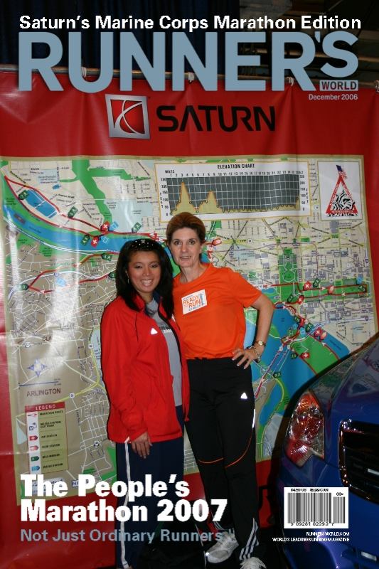
Best of all, I felt grateful to be able to run it at all especially since I’d had a string of weekend runs with no rests, from Chicago marathon early in the month, Staten Island half, Detroit half, all without a weekend off and with never a proper long run. My BFF Maricar got me over the finish line in our usual time (5:29) though I might have done a 6 hour one had I been left on my own (and she would have done a faster time without me.) An interesting statistic?: Of the 11 runners we knew who were signed up, 5 did not make it to the start line. Maricar is scheduled for the NYC Marathon next weekend so I didn’t feel much guilt about holding her back. The only flaw of the event was the return bus set up which was so bad that I’m sure Marathon Guide will hear a lot about it which is a shame because so much else went perfectly.

I’d picked up Maricar at school on Friday, driving through the usual Baltimore traffic at rush hour, but making it just in time to rush through the Expo and into the pasta dinner as they were closing up. We sure got our $9 worth of food and it was in a tent directly outside the Armory where the Expo was held. We’d been somewhat disappointed at the clothing, both in style, design and lack of sizing but we managed some purchases anyway, some of which had to be returned the next day.

We are always mindful that we only choose “destination marathons” and this was no exception. It is however sometimes an odd choice to use our feet touring on Saturday followed by Sunday’s marathon. We were smarter than usual (Yosemite hiking before San Francisco as an example) and indulged in the Old Town Trolley tour which is a hop on/hop off deal and got around the mall, basic monuments, Georgetown and out to the national cathedral, getting ourselves back to the Hyatt Regency Capital Hill in time for the Dine-In with entertainment.
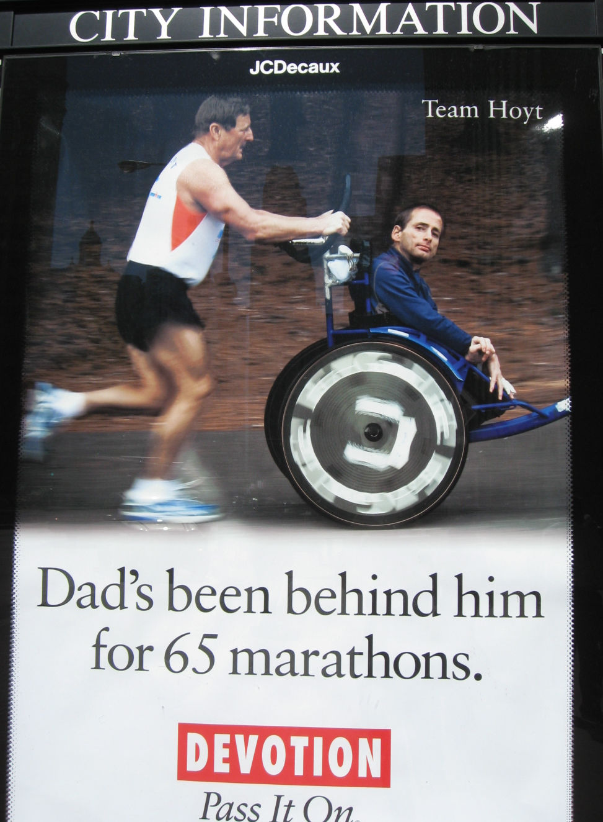

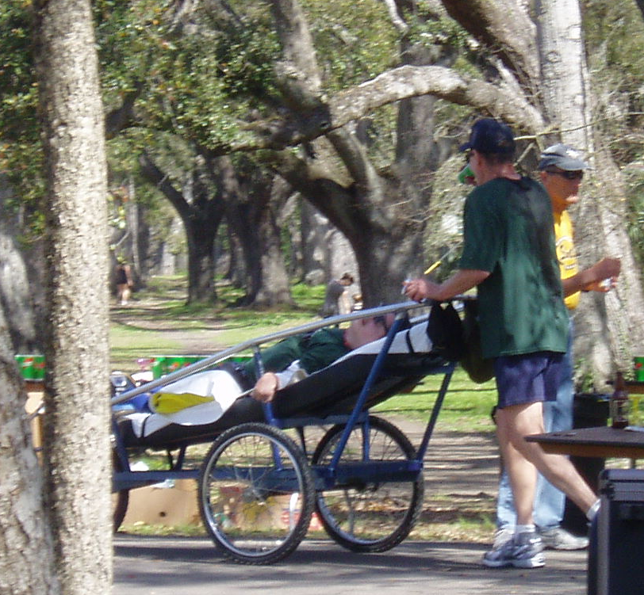
It was at the Hyatt’s Dine-In we met John and Tyrone. John is an ex-Marine, father of a couple girls, who is not only a runner but a very inspirational one. Remember Dick and Rick Hoyt? So similar, but maybe even more touching in that John met Tyrone through his church and found that Tyrone (age 56 with Cerebral Palsy) needed a reason to live and now they run together. We’d seen them on the course during February’s Mardi Gras Marathon and taken a picture of them, at first thinking they were Dick and Rick.

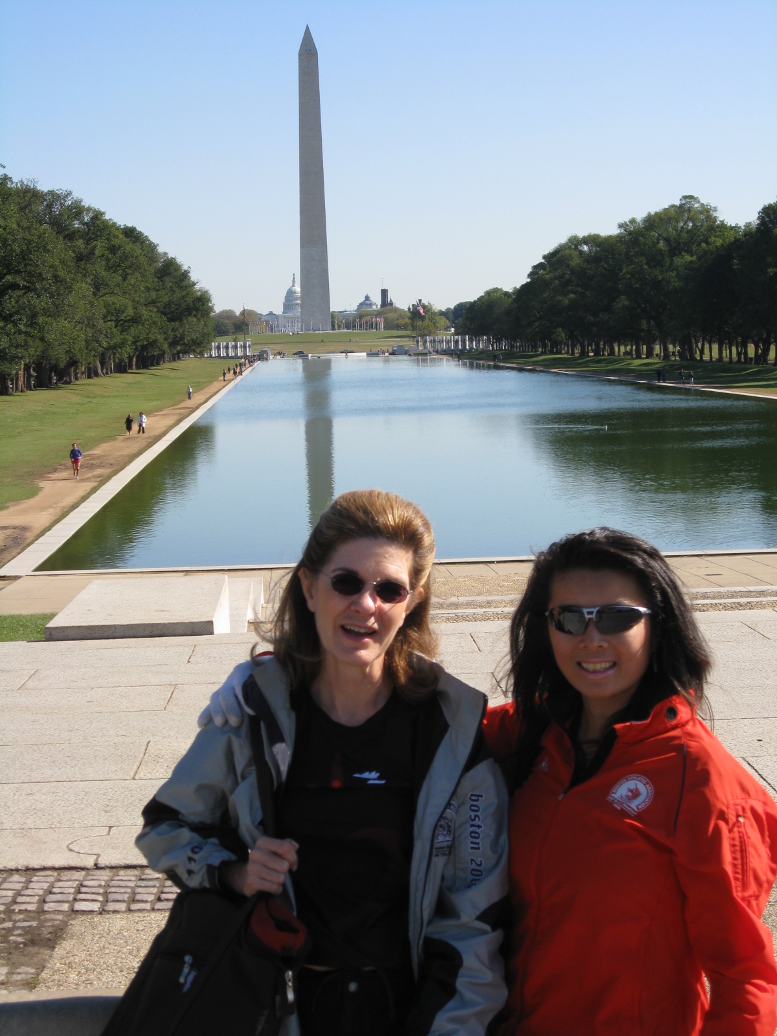
Maricar had been scheduled to return to NJ with Bernie on Sunday night so she could teach Monday morning, and I was planning to stay over until Tuesday night, but something had happened causing Bernie to rush home earlier than planned, leaving Maricar without a ride. It all worked out okay with her scurrying to find a substitute teacher, prepare class lessons and update her classroom web site. We ended up with a huge walking touring day staying in the city until 7pm and seeing many of the sites that we’d only seen by Trolley on Saturday, or running past on Sunday. I think we did a half marathon touring and managed a couple of good meals too, a necessity to fill that huge void that’s always left after a marathon.

All in all, we felt honored to run in the Marine Corps Marathon 2007. It had been Maricar’s very first marathon ever, in 2000, and she’d felt that she’d missed the fun of it and all the sites, being more into speed and less into “destination marathons” so it was my good fortune to be able to take in all the sites, what she called the “Hot Marines” and I couldn’t disagree, and turn in a very respectable finishing time while having a good time finishing.

Semper Fi.

MCM STORY:
In 2005, the Marine Corps Marathon closed out in just 62 hours and 19 minutes. In its long history, the MCM has not only made a name for itself in sheer size as the 5th largest US Marathon and 8th in the world, but stands as the largest marathon in the world that doesn’t offer prize money, earning its nickname, "The People's Marathon."
30 years of MCM history can all be traced back to one man Colonel Jim Fowler, and big idea. According to Fowler, "After the Vietnam War, popularity of the military services declined in the eyes of many. At the same time, distance running was gaining considerable positive attention." This thought process lead Fowler to write a memo to his superior, General Michael Ryan, dated 17 October 1975, outlining his idea for a Marine Corps Reserve Marathon, to promote community goodwill, showcase the Marine Corps, serve as a recruiting tool and finally, to give local Marines an opportunity to qualify for the legendary Boston Marathon. Fowler’s memo stated, “The name marathon evokes military history and is the kind of event which the public finds in consonance with the image of the Marines." General Ryan loved the concept and helped it receive approval from the Commandant of the Marine Corps, General Louis Wilson.
With the approval of the CMC, the planning process began. Word of the marathon spread quickly through the ranks, reaching as high as the Secretary of the Navy, William J. Middendorf, who had enthusiastically embraced the event and donated a handsome trophy to be awarded to the overall winner.
With the backing of the Secretary of the Navy, many people jumped aboard the Marathon bandwagon. When Gunnery Sergeant Alex Breckinridge, a member of the 1960 Olympic Marathon Team heard about the Marathon, he too wanted to do his part to ensure the success of the Marathon. Fowler observed "the presence of Alex Breckinridge during meetings with the local jurisdictions was of incalculable value. Here was a staff noncommissioned officer who had been a member of the US Olympic Team. I could not ask for a more impressive ambassador on behalf of the program we were trying to establish".
Thanks to word of mouth gains were being made on the publicity side. The advertising agency, J. Walter Thompson, which had the Marine Corps account "arranged" for Runner’s World magazine to join the effort. In the June 1976 edition of Runner’s World, there was a full-page advertisement for the First Annual Marine Corps Reserve Marathon. The picture depicted Paul Kelly and Dick Sullivan running in front of the Iwo Jima Memorial. The message included a brief description of the course, awards, time, location and a coupon, which runners could send in requesting more information. It was at this time that Col. Fowler dubbed the race Ryan’s Run, in honor of the General.
Through the dedication and efforts of the Marine Corps Reserve, under the direction and leadership of Col Fowler and General Ryan, the first MCM was held on 7 November 1976 and welcomed 1,175 participants (New York only had 123 participants in its first year, 1970) to the Arlington, VA start line. Runners began and ended the inaugural race at the Marine Corps War Memorial, fondly referred to as the Iwo Jima monument, a fitting location for a Marine Corps event.
A successful first year reaffirmed Fowler’s belief that a Marine Corps marathon would be well received in the community and beneficial to the Marine Corps. As planning began on the second event, Fowler had a meeting with the Chief of Police for the District of Columbia, Maurice J. Cullinane. Fellow Marine Herb Harmon was with the Corporation Counsel’s Office and had a good relationship with Chief Cullinane. The meeting resulted in a parade permit that allowed the marathon to change its course and yielded the scenic route through Washington that all future competitors would enjoy. Each route modification required new measurements and re-certification by the AAU. A wheelchair category was added to the second Marathon in addition to the route change. With the heightened publicity from the first event and a new, more scenic course, the Marine Corps Reserve Marathon was thrilled to welcome 2,655 runners to the second race field. With the big idea and littlest details firmly in place, the Marine Corps Marathon took off. By the early 1980’s, the planning requirements for the MCM had grown so much, that Marine Corps Base Quantico was tasked with putting on the annual event. In 2005, the MCM registered its largest race field ever, 30,000 runners. More than 18,000 runners crossed to finish to behold the same memorable site as the finishers in the first MCM, the Marine Corps War Memorial, filling runners with pride for not only their accomplishments, but for their country and their Corps.
Of the original 1,175 finishers to cross the Arlington, VA start line, only five have gone on to run the Marine Corps Marathon each fall. Will Brown, 58 of Raleigh NC; Roger Burkhart, 66 of Gaithersburg; MD; Matthew Jaffe, 63 of Rockville, MD; Al Richmond, 64 of Arlington, VA; and Mel Williams, 65 of Norfolk, VA, better known as the Groundpounders, have participated in all 30 Marine Corps Marathons. Between the five of them, these men can remember every twist and turn the MCM has taken over its thirty-year history.

the early years
Brown: “I was a Reservist at the time, and I decided to run my first marathon. I got a side stitch after five miles and it stayed with me the rest of the race. I was young and I had heard that marathons hurt so I just stuck with it and kept running.”
Burkhart: “The course took us by National Airport and they had to stop traffic for us. Runners usually have to stop for traffic, but it was nice that this time they had to stop for us. Also I ran my best time ever that year, so that’s something to remember.”
Richmond: “I had just come back on active duty in 1976 at reserve headquarters and they were already in the process of organizing the first MCM. I was working and not planning to run, but about August, I was getting ready to workout and this Col. came in, all excited because he had just finished his first 10-miler. I thought to myself, if that old guy can do it, I ought to be able to do it and the rest is history.”

annual return
Brown: “I enjoyed the experience so much I kept coming back. One thing led to another and I had done them all.”
Richmond: “The tradition keeps me coming back. It is a good race, extremely well supported, lots of people out there and stops for water, once I got into it, I was a Marine and wanted to continue on with it. Fall wouldn’t be complete unless I run the MCM.”
Williams: “I started teaching at ODU about marathon running and fall semester final was to run MCM. After I ran the 10th MCM, I said well, I need to keep the streak going and see how long it lasts.”

other runners
Jaffe: “There are far more regular people running. In the early years it was just running buffs that ran the marathons. People now will run it for enjoyment and to say they finished a marathon.” Burkhart: “Before you would only get the nuts to come out and run a marathon. Now everyone wants to do it and they are more casual about running. They do it for fun.” Williams: “It’s not a race for the elite but for the people- that’s why they call it ‘The People’s Marathon’.”

marine involvement
Richmond: “I always liked the concept of the young lieutenants at the end and the various Marines along the way. They are totally supportive, always there, and there’s always enough of them. The organization and support keeps getting smoother and better and help keep it fresh.” Jaffe: “The support from the MCM, the volunteers, and the Marines is just so great. It took me 4 hours to run that first race and I think they were out there cheering longer than I was running. Still the Marines and everyone are handling it very well. They are controlling the size and the crowd well.” Williams: “They have made this a very high quality national race by gradually expanding and changing the course to make it better: adding regular water and goo stations on the course, improving the medals, the quality of the t-shirts and all the support and Oorahs from Marines, all these little changes have made the biggest difference."
The Groundpounders are poised for this year's race and look to the future with plans of running the MCM as long as they can. "We've talked about it," Williams said. "The plan is to go through the fiftieth anniversary. Then we'll go to till last man standing."

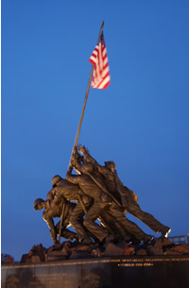
ANNUAL MARINE MARATHON BEGINS AND FINISHES AT WORLD-FAMOUS MARINE CORPS WAR MEMORIAL CORPS OBSERVES 60TH ANNIVERSARY OF HISTORIC BATTLE AND FLAG-RAISING
The statue, portraying six servicemen who raised the American flag on the island,is inscribed, "In honor and in memory of the men of the United States Marine Corps who have given their lives to their country since November 10, 1775."
"The monument before us has been raised to provide a visible symbol of the immortality of those whom we honor," said General Lemuel Shepherd, Jr., the 20th Marine Commandant at the dedication. "To all who shall ever view this Memorial it will speak of the courage, the spirit, and the greatness of the American people, the people from whom these men and their ageless comrades came."
Clint Eastwood, along with co-producer Steven Spielberg, is filming the Iwo Jima battle story, its heroics and its tragedies, based on the book "Flags of our Fathers: Heroes of Iwo Jima," by James Bradley, whose father was one of the "flag raisers" that perilous day on Mt. Suribachi. The strain of what these men endured in the 36-day and night battle for Iwo Jima is vividly engraved in the marvelously detailed Marine sculpture.
Japanese forces are still only yards away as Corporal Harlon Block grasps the bottom of the 100-pound galvanized drainage pipe; just behind him, 19-year-old Private Rene Gagnon lends an elbow and his shoulder to the push; Private Sousle wraps both hands around the pole; Navy medical corpsman Pharmacists Mate John Bradley, having dropped a load of bandages, manages to grasp the pipe. Sergeant Mike Strank maneuvers the pipe into position. And the searing image of Pima Indian Private Ira Hayes, forever remembered for his outstretched hands, at first not quite reaching the pole, but signifying to this day the intense struggle for victory.
Of these men, three, Strank, Block and Sousley, would die within hours or days. The surviving trio, with severely wounded Bradley on a stretcher, would be evacuated from the island into a world in which some would face the psychological equivalent of battle. The flag-raisers are all dead now. But in spirit, there is a seventh serviceman, a Marine, present. Larry Ward wasn’t at Surabachi that day, but the 31-year-Marine veteran has fought and been wounded in Marine battles in Korea, three tours in Vietnam and Granada. Larry’s retired now, and he’s become something of an institution at the monument, readily identifiable with his Marine drill instructor’s hat. Larry is the monument’s official volunteer monitor and factotum.
Larry is loaded with fascinating lore. Did you know that on this single day, Easy Company won a Medal of Honor, four Navy Crosses, two Silver Stars, plus a smattering of Purple Hearts? “Iwo Jima is the only battle in Marine history where the Marines suffered more casualties (25,851) (7,000 dead) than the Japanese (22,000),” says Larry. The flag-raising Easy Company started the 33-day fight with 310 men and only 50 survivors boarded the homeward bound ships.
The Japanese entrusted Iwo Jima’s defense to their best military officer, Lt. General Tapamichi Kuribayashi. His tactics: fight underground. There were more than 1,500 rooms carved into the rock and connected by16 miles of tunnel. Kuribayashi explained his broader strategy in a letter to his wife: If American casualties are high enough, Washington will think twice before launching an attack on Japan.” This was a widely shared view among top Japanese military and civilian leaders, including Emperor Hirohito. And it was not entirely fatuous. In Washington, President Truman and General George Marshall were deeply apprehensive about an invasion projected to cost 200,000 American lives.
In the early hours of 19 February, 1945, 70,000 marines of the 4th and 5th Marine Divisions landed on the black coral sand beaches. A major objective was to take Mount Suribachi, an extinct volcano, which dominated the entire island. On the morning of 23 February, elements of Easy Company, 2nd Battalion, gained provisional control over the summit, and a small flag was raised. Mike Strank was not satisfied: “Get a bigger one so that every Marine on this cruddy island can see it.” His men located a larger flag on a landing ship. That afternoon, with Japanese troops still active in the area, the six men raised the new flag. Photographer Joe Rosenthal caught the scene with a single exposure, and won a Pulitzer Prize for what is now among the most famous photographs in history. Navy Secretary James Forrestal, who was on a ship watching the flag raising that day, put it best: “The raising of that flag on Suribachi means a Marine Corps for the next five hundred years.”
Tradition has it that there’s no such thing as an “ex” Marine and Larry embodies this continuing love of the Marine Corps. Recently, the young widow of Marine Cpl. Joseph McCarthy, killed in Iraq, visited the monument. She was wearing a black metal armband in memory of her husband. After talking to Larry, she gave him the armband to keep alive the memory of her husband. Larry always wears it when serving his Marine duty at the memorial. It’s this sort of devotion that Eastwood and Spielberg will have to evoke in their film.

Maricar’s Photo Story:
http://download.yousendit.com/AD1E00C62D75A803

